
School of Sciences | Department of Computer Science and Engineering

Replace this with the title of the thesis

Replace this with the subtitle (if applicable, if not delete the line)

Master of Science
In enter your discipline

Enter you name here

© Enter the month and year you are submitting

Acknowledgements

Abstract
Literature reviews require researchers to search multiple scholarly databases because publications are distributed across different platforms. Each database maintains distinct coverage and metadata standards. Researchers must query these systems individually, identify duplicate entries manually, and organize results before beginning actual analysis. With research output increasing roughly 4% per year, this fragmentation imposes growing time costs on the research process.
This thesis describes AI Scholar, a system designed to integrate multiple scholarly databases through one search interface. The implementation uses asynchronous queries to contact databases simultaneously, reducing total search time compared to sequential approaches. Deduplication works by matching Digital Object Identifiers when available and comparing titles using fuzzy string matching for papers lacking identifiers. Results get ranked by combining several factors: how often papers have been cited, how recently they were published, and which database provided them. The system also connects to language models to generate brief summaries of paper content. The architecture separates database-specific code into provider modules, which convert different data formats into a standard model that other components can work with.
The work shows that addressing database fragmentation doesn't require new technology. What already exists—API access to databases, text processing algorithms, fuzzy matching techniques—can be combined to produce a functional system. AI Scholar reduces the manual effort involved in multi-database literature searches by handling queries, removing duplicates, and organizing results automatically. Testing confirmed that this approach functions reliably for standard research workflows.

Table of Contents
Acknowledgements 2
Abstract 3
Table of Contents 4
Table of Figures 7
Table of Tables 8
1 Introduction 10
1.1 Overview 10
1.2 Aims and objectives 14
1.3 Research Questions and Scope 16
1.4 Thesis Structure and Contribution 18
1.5 Summary 19
2 Project Scope 21
2.1 Introduction 21
2.2 Motivation 22
2.2.1 Existing System Description 25
2.2.2 Project Scope 27
2.2.3 Performance/Behavior Requirements 29
2.2.4 Technical Constrains 30
2.3 Feasibility Study 32
2.3.1 Financial Feasibility 32
2.3.2 Operational Feasibility 33
2.3.3 Technical Feasibility 34
2.4 Related Work and Literature Review 35
2.4.1 Academic Search 35
2.4.2 AI-Enhanced Scholarly Discovery Tools 37
2.4.3 Bibliographic Deduplication Techniques 38
2.4.4 Ranking and Recommendation in Scientific Literature 40
2.4.5 Gaps In Existing Research 41
2.5 Risks and Assumptions 43
2.6 Summary 45
3 Analysis and Design 46
3.1 Introduction 46
3.2 System Architecture Overview 47
3.2.1 Component Interaction Workflow 50
3.2.2 Architectural Design Rationale 52
3.3 Component Design 53
3.3.1 Controller Layer 53
3.3.2 Service Layer 54
3.3.3 Provider Layer 57
3.3.4 Data Models 59
3.4 System Architecture and Design 60
3.4.1 Overall Architecture 60
3.4.2 Component Interaction 62
3.4.3 Deployment Architecture 64
3.5 Summary 68
4 Implementation and Testing 70
4.1 Introduction 70
4.2 Implementation Issues / Development Environment 71
4.2.1 Programming Language and Framework 71
4.2.2 Programming Language and Framework 72
4.2.3 External APIs and Services 74
4.2.4 Hardware Requirements 76
4.3 Implementation Details 76
4.3.1 Core Components Implementation 76
4.3.2 Key Algorithms 84
4.3.3 Database Implementation 92
4.4 User Interface Implementation 99
4.4.1 Registration Page 99
4.4.2 Login Page 101
4.4.3 Home Page / Search Interface 103
4.4.4 History 108
4.4.5 Profile 109
4.5 Testing 110
4.5.1 Component Testing 110
4.5.2 Integration and Performance 111
4.5.3 Interface and Api testing 111
4.5.4 Error Handling 111
4.6 Summary 112
5 Conclusions and Future Work 114
5.1 Introduction 114
5.2 Conclusions 115
5.3 Future Work 118
5.3.1 Additional Database Integration 118
5.3.2 Export and Integration Features 119
5.3.3 Mobile Interface 119
5.3.4 Monitoring and Analytics 119
5.4 Summary 120
Bibliography 122
Appendices 124
Appendix A List of Acronyms 124
Appendix B System Installation and Deployment Guide 126

Table of Figures
Figure 1: Comparison of the current fragmented literature search workflow and the proposed unified AI Scholar system 12
Figure 2 High-level system architecture of AI Scholar, illustrating the separation of concerns across the Presentation, Controller, Service, and Provider layers 47
Figure 3 Sequence diagram detailing the component interaction workflow during a user search request, highlighting the parallel execution of external API calls and the asynchronous generation of AI summaries 50
Figure 4 Deployment architecture of AI Scholar, showing the central Flask application routing traffic between the user browser, local database/cache, and external scholarly and AI APIs. 64
Figure 5 Implementation of the search endpoint in the SearchController. 76
Figure 6 SearchService Class 77
Figure 7 AIService Class 78
Figure 8 PaperService Class 79
Figure 9 RankingService Class 80
Figure 10 ArxivProvider Class 81
Figure 11 Paper Model Class 82
Figure 12 Asynchronous Search Execution Algorithm 84
Figure 13Asynchronous Search Execution Algorithm 2 84
Figure 14 Deduplication Algorithm 86
Figure 15 Similarity Example 87
Figure 16 Author Overlap Example 87
Figure 17 Merging Mechanism 88
Figure 18 Ranking Algorithm 89
Figure 19 Relevance Prompt 90
Figure 20 Database Schema 92
Figure 21 Connection Management Mechanism 94
Figure 22 Save_Paper Method 95
Figure 23 Retrieving Saving Papers 95
Figure 24 Cache Queries 96
Figure 25 Retrieve Cached Items 96
Figure 26 Migrations Script 97
Figure 27 Registration Page 98
Figure 28 Login Page 101
Figure 29 Home Page / Search Interface 102
Figure 30 Search Results 106
Figure 31 History Page 107
Figure 32 Profile Page 108
Figure 33 Proposed Future RoadMap 117
Figure 34 Project .env configuration file setup 126
Figure 35 Cloning repository from Github 126
Figure 36 Creating virtual Environment 126
Figure 37Installing project dependancies 127
Figure 38 Recreating the databases 127
Figure 39 Executing the python project 127

Table of Tables
Table 1 Comparison of existing scholarly discovery tools and the proposed AI Scholar system. 42
Table 2 Python Attributes 71
Table 3 Ai Scolar Project Layout 71

Introduction

Overview
Research output has grown tremendously in recent decades. This is not speculation—it has been measured and documented through multiple bibliometric studies. Bornmann, Haunschild, and Mutz (2021) analyzed publication records from the major databases—Scopus, Web of Science, Dimensions, and Microsoft Academic—and found the growth rate averages about 4.1 percent per year. At that rate, the total number of published papers doubles every 17 years or so. The growth isn't uniform across fields. Life Sciences sees about 5.1 percent annual growth, while Physical and Technical Sciences are closer to 5.5 percent. Depending on the academic discipline, it might be even more dramatic.
For researchers trying to actually do a literature review, this creates a real problem. The issue isn't just the quantity—it's that papers are scattered everywhere. Scopus (Elsevier, 2025) and Web of Science (Clarivate Analytics, 2025) are the main commercial databases. They have extensive coverage but cost institutions between $15,000 and $50,000 per year. They also restrict programmatic data access, requiring queries to be routed exclusively through their proprietary interfaces, Programmatic data extraction is restricted with code. Then there are the open platforms: arXiv (Cornell University, 2024) for preprints in physics, math, and computer science; CORE (CORE, 2024) which pulls together open-access papers from institutional repositories; OpenAlex (Priem, Piwowar, and Orr, 2022), which provides free access to metadata on millions of scholarly works; and CrossRef (Hendricks, Tkaczyk, Lin, and Feeney, 2020), which maintains standardized publication metadata. Each covers different papers. Each uses different metadata standards. Searching one database yields a specific set of results, while applying the same query to another platform frequently returns a different collection of papers. This is partly about what papers each database has indexed, partly about how their search algorithms rank results.
What information scientists refer to as information overload is a significant component of the situation described here. Bawden and Robinson (2009) define information overload as a condition in which the volume, diversity, complexity, and dispersion of information impede rather than support effective cognition and decision-making. For the academic researches, this phenomenon manifests in concrete and recurring ways. Searches expanded in major databases such as Scopus may return hundreds of results, while similar or even the same queries in platforms like OpenAlex returned overlapping yet non-identical sets of publications. Researchers must then manually track retrieved papers, determine whether records across databases represent duplicates or distinct works, and organize the material into a usable system. These activities require substantial time investment—often several hours per week for active researchers. Consequently, a significant portion of researchers’ efforts is diverted toward administrative and organizational tasks, reducing the time available for critical reading, analysis, and engagement with core research questions.
There's another problem too. Because different databases have different papers and rank them differently, researchers might be systematically missing relevant work. Or they might see a skewed sample depending on which database they happen to use most. The newer AI tools like Semantic Scholar (Allen Institute for Artificial Intelligence, 2024), ResearchRabbit (ResearchRabbit, 2024), and Connected Papers (Connected Papers, 2024) by displaying citation networks and suggesting related papers. But they operate independently from each other and from the main databases. They don't really solve the fragmentation problem—they just add more tools to the pile.
But some things have improved. Open-access infrastructure has gotten substantially better over the last ten years. CORE now aggregates content from thousands of repositories and provides free Application Programming Interface (API) access, enabling programmatic querying (CORE, 2024). OpenAlex was specifically built as a free alternative to proprietary databases, with over 200 million papers indexed and APIs designed for researchers to use (Priem, Piwowar, and Orr, 2022). CrossRef keeps metadata on over 106 million publications and grows about 11 percent annually (Hendricks et al., 2020). These exist now. Five or ten years ago, this infrastructure didn't exist. The technical landscape has fundamentally changed.
At the same time, AI and natural language processing got better. Text summarization algorithms can now capture the main findings and methods from a paper reasonably well, though they still struggle with highly technical language and specialized notation (Zhang, Zhao, Saleh, and Liu, 2023). Extracting key phrases and concepts from documents works with decent accuracy now. Large language models can understand academic text well enough to find papers that are conceptually similar, not just keyword matches (Brown, Mann, Ryder, et al., 2020). These capabilities didn't exist in their current form a few years ago. Put together—the availability of open data and these AI capabilities—it becomes possible to actually build something useful.
This thesis describes AI Scholar, a system that brings together these pieces. The platform searches across five major data sources simultaneously: arXiv (Cornell University, 2024), Semantic Scholar (Allen Institute for Artificial Intelligence, 2024), CrossRef (Hendricks et al., 2020), CORE (CORE, 2024), and OpenAlex (Priem, Piwowar, and Orr, 2022). It does three main things. First, it handles duplicates automatically—when the same paper shows up in multiple databases, the system recognizes it's the same paper. Second, it ranks results sensibly instead of just using whatever ranking each database provides. Third, it summarizes papers and extracts key concepts to facilitate rapid comprehension of the content. The goal isn't to replace existing databases. It's to sit on top of them—to provide one interface to query all of them at once and do the tedious work of organizing results automatically. Figure 1.1 illustrates this transition from a fragmented search process to the unified workflow provided by AI Scholar.

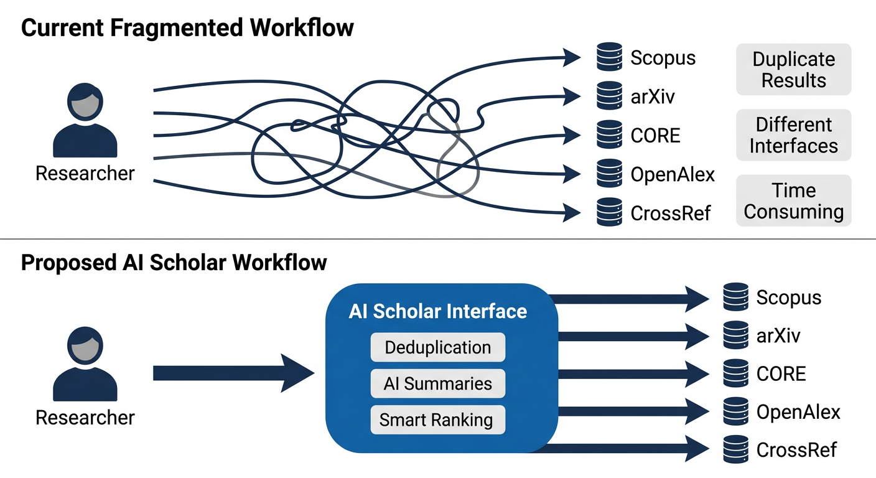
Figure 1: Comparison of the current fragmented literature search workflow and the proposed unified AI Scholar system
The manner in which the system was developed is as significant as the functionality it provides. Its design follows established software engineering practices, employing a layered architecture based on the Model–View–Controller (MVC) pattern. This approach was selected because it is well understood and supports extensibility, allowing new components to be introduced without disrupting existing functionality also it helps new developers to have a clean understanding of the code structure. The development process did not prioritize theoretical optimality; instead, it emphasized robustness and practical usability under real-world conditions. The underlying rationale is that systems which fail outside ideal circumstances offer limited value compared to those that produce acceptable results in imperfect and variable environments. Academic researchers operate across heterogeneous contexts, including differences in hardware, institutional access, and technical expertise. Consequently, a system capable of graceful degradation in the presence of errors or constraints is more valuable than a theoretically optimal system that is brittle in practice. This principle guided the overall design and implementation decisions.

Aims and objectives
The main goal of this thesis is to develop a system that helps researchers find papers more efficiently when conducting literature reviews. The secondary aim is to demonstrate that such a system can be built using infrastructure and tools that already exist, rather than requiring entirely new inventions. If this approach proves successful, it suggests the fragmentation problem described earlier is not unsolvable—it is simply a matter of integrating existing resources.
To accomplish these goals, three specific objectives have been established. The first objective is to design an integrative architecture capable of connecting to multiple databases and querying them simultaneously. This is more complex than it initially appears. The design must accommodate how each database functions—Scopus (Elsevier, 2025), Web of Science (Clarivate Analytics, 2025), arXiv (Cornell University, 2024), CORE (CORE, 2024), OpenAlex (Priem, Piwowar, and Orr, 2022), and CrossRef (Hendricks, Tkaczyk, Lin, and Feeney, 2020)—and determine how to enable communication among them. Each platform maintains different data fields, different methods of representing identical information, and different capabilities. The architecture must identify commonalities across systems, manage differences appropriately, and present results to users without losing important contextual information about result origin. Success in this objective means achieving simultaneous querying of all five data sources and returning unified results that are comprehensible and actionable.
The second objective involves implementing intelligent analysis layers on top of the unified data infrastructure. This encompasses three distinct components. First, automated deduplication mechanisms that identify when the same paper appears across multiple databases—an occurrence that happens frequently but inconsistently, requiring programmatic handling rather than manual intervention. This deduplication logic must recognize when two database records represent the same publication despite variations in formatting or nomenclature. Second, a relevance ranking system that prioritizes results sensibly. Individual databases employ different ranking algorithms based on their respective methodologies. The ranking system must integrate multiple factors—relevance to the query, publication date, citation count, and source database—rather than accepting the ranking provided by individual databases. Third, integration with large language model technologies to generate automated paper summaries and extract key concepts. When researchers receive search results, rapid comprehension of paper content without full-text reading is valuable. Machine-generated summaries facilitate this objective.
The third objective is the technical verification of the system, ensuring that asynchronous queries function correctly, deduplication algorithms accurately merge overlapping records, and system latency remains within acceptable limits for interactive use.
The implementation approach involves several sequential and different phases. The first phase consists of detailed analysis of each data source individually—the papers indexed, metadata organization, data collection, API capabilities, and limitations. Comprehensive documentation of these characteristics is necessary. The second phase involves architecture design capable of abstracting these differences and presenting a unified interface. A standard Model-View-Controller (MVC) architectural pattern will be used because it is well-established and permits modification or component addition without disrupting existing functionality. The third phase encompasses system implementation—API integrations, deduplication algorithms, ranking system algorithm, and (LLM) Large Language Model integration. Testing occurs throughout to verify component functionality.
An important clarification regarding system design: the objective is not to construct a theoretically perfect system. Rather, the goal is developing a system that functions effectively in real-world conditions while maintaining transparency regarding limitations. The deduplication mechanism will not identify every duplicate. The ranking algorithm will not prove optimal for all use cases. Comprehensive indexing of all existing papers is not feasible. Some relevant results may be missed because constituent data sources lack comprehensive coverage. However, a system that functions adequately for most researchers most of the time possesses greater practical value than a theoretically perfect system that functions poorly under realistic conditions. This pragmatic approach guides all design decisions.
Upon completion, this thesis will produce three concrete deliverables. The first is a functional system—actual code and infrastructure available for researcher use. The second is comprehensive documentation explaining system construction, design decision rationale, accepted trade-offs, and system limitations. The third is an evaluation report demonstrating whether the system achieved stated objectives—specifically whether it enables researchers to conduct superior literature reviews. These three deliverables collectively address whether the fragmentation problem is solvable using currently available infrastructure and technology.

Research Questions and Scope
The work presented in this thesis is organized around three research questions. The main question is straightforward: can a single unified interface to multiple scholarly databases actually reduce the fragmentation problem? Can it address information overload by providing integrated access to research across different platforms? That question motivates everything that follows. Two more specific questions support it. First: how much do deduplication, machine learning ranking, and AI summarization actually improve paper discovery compared to searching databases individually? Second: To what extent can algorithmic deduplication and asynchronous API aggregation programmatically reduce the duplication of records retrieved from distinct scholarly databases?
The work focuses on scholarly databases—the research publication platforms that matter most for academic work. Five specific databases were selected: arXiv (Cornell University, 2024), Semantic Scholar (Allen Institute for Artificial Intelligence, 2024), CrossRef (Hendricks, Tkaczyk, Lin, and Feeney, 2020), CORE (CORE, 2024), and OpenAlex (Priem, Piwowar, and Orr, 2022). The reason for this selection is deliberate. These represent a good mix of established and newer open platforms. They have APIs available for researchers to query. They index papers across different academic fields reasonably comprehensively. Working with these five systems demonstrates how to integrate across different architectures while using infrastructure designed specifically for research use.
The implementation itself is clearly defined. Build an architecture that works with all five databases. Implement deduplication so the same paper appearing in multiple databases gets recognized as one item. Develop a ranking system that makes results more useful. Connect large language models to summarize papers. The end result is a working prototype. Something functional that proves the idea works. It's not attempting to be production-grade or to cover every possible scenario. Using established techniques and existing tools keeps the development manageable and lets the focus stay on solving the integration problem specifically.
The timeline for this work is realistic. Six to nine months for development, implementation, and evaluation is standard for thesis work. That timeframe allows proper design, solid implementation, and meaningful testing. It's enough time to build something complete and evaluate it thoroughly. Using technologies and tools that individual researchers can reasonably access means the approach is reproducible. Other researchers interested in this problem can build on it or extend it themselves without requiring extensive infrastructure.
What the thesis actually delivers is valuable. It shows how to successfully connect multiple open data sources into one interface. It demonstrates that deduplication and ranking actually work to improve discovery. It shows that language models can summarize research findings usefully. It provides evidence from real researchers about whether this improves how they work. It creates a foundation that future work can build on—adding more databases, improving ranking, or adapting it for specific research communities.
The approach works because it targets a real problem with practical solutions. Using open infrastructure and established techniques keeps things feasible while actually addressing gaps that exist in current research tools. Testing with actual researchers rather than just simulating use provides real evidence about whether the idea works. The focus on integration rather than trying to solve every related problem allows solid, concrete contributions. That's what makes this work meaningful.

Thesis Structure and Contribution
The work that follows is organized to mirror how the system actually gets built.

Chapter 2 is a literature review. It covers prior work on research discovery systems, how information retrieval actually works, and what exists in academic database infrastructure. The goal of this chapter is to establish what's already known about information overload in research contexts, what aggregation approaches have been tried, and which machine learning techniques matter for deduplication and ranking. By the end of Chapter 2, it's clear how this work fits within the broader research community and why the proposed approach differs from existing solutions.
Chapter 3 describes the system design and architecture. This section details the technical implementation—how AI Scholar brings together data from multiple sources, how the API design works for querying each database, what the overall system components are. The architecture section explains something non-obvious: how to take databases that are fundamentally different and unify them through a common data model. It addresses practical questions like which design patterns let the user add new databases later without rebuilding everything. By the end of this chapter, the technical foundation is clear.
Chapter 4 is implementation. It explains which specific technologies were selected and why. It walks through how the core components actually got built—the deduplication algorithm, the ranking system using machine learning, how large language models got integrated for summarization. Each implementation choice gets justified. Why use this approach instead of that one? What technical requirements drove the decision? What practical constraints matter? The chapter also covers testing—how to verify that each component works correctly and that they work together as an integrated system.
Chapter 5 concludes the thesis, summarizing the technical achievements, acknowledging system limitations, and proposing directions for future feature development.
What this thesis contributes is straightforward. It demonstrates that an effective research discovery system using infrastructure can be built that already exists and techniques that are already established. Fundamental breakthroughs in database technology or machine learning are not strictly required. Instead, you need thoughtful integration of existing resources to address real gaps in current tools. The thesis delivers both a working prototype and concrete evidence about whether this approach actually provides practical value to researchers. It also documents design patterns for building multi-database aggregation systems and provides methodology for evaluating whether discovery systems work. Beyond the system itself, it offers practical insights: which challenges in multi-database integration are actually solvable with reasonable effort, and which are fundamentally harder problems.
Multiple audiences can benefit from this work. Researchers in computer science can see a concrete example of how to apply integration and aggregation techniques to a real problem. Academic librarians and infrastructure teams can learn about approaches to improving research discovery through platform integration. Individual researchers and students doing literature reviews get a tool that actually saves time and reduces frustration with searching multiple databases. At a broader level, the thesis demonstrates an important principle: improving research infrastructure does not inherently require massive institutional budgets or large teams. Thoughtful work by individual researchers can produce genuine improvements.

Summary
The introduction has laid out why this work matters and what it covers. The basic facts are straightforward. Research output keeps growing—between 4 and 5 percent per year depending on the discipline, as Bornmann, Haunschild, and Mutz (2021) documented. More papers get published every year. That growth alone wouldn't be such a problem if everything was in one place. The real issue is that papers are scattered across multiple databases. Scopus (Elsevier, 2025) and Web of Science (Clarivate Analytics, 2025) are the big commercial ones. They cost institutions serious money—$15,000 to $50,000 per year. Then there are the open platforms: arXiv (Cornell University, 2024) for preprints, CORE (CORE, 2024) pulling together open-access papers, OpenAlex (Priem, Piwowar, and Orr, 2022) with free metadata access, and CrossRef (Hendricks, Tkaczyk, Lin, and Feeney, 2020) with standardized records. Each has different papers. Each uses different metadata standards. This fragmentation means researchers have to search multiple databases, manually figure out which papers are duplicates, and spend hours organizing results. That's administrative overhead that takes away from actual research.
Bawden and Robinson (2009) define information overload as a situation in which the large amount of information spread across different sources actually makes thinking more difficult. In research, this problem often arises when a search in one database produces one set of papers, while the same search in another database returns a different set. This can leave researchers unsure whether they have identified all relevant work. Tools like Semantic Scholar (Allen Institute for Artificial Intelligence, 2024), ResearchRabbit (ResearchRabbit, 2024), and Connected Papers (Connected Papers, 2024) try to help by showing citation networks and suggesting related studies. Still, each tool works on its own, and while they can be useful, they do not solve the underlying issue of fragmentation and instead add more separate systems for researchers to manage.
What's changed recently is that both the infrastructure and the technology have improved. Open-access platforms like CORE and OpenAlex now provide free, programmatic access to data. That wasn't the case five years ago. Machine learning and natural language processing have gotten better too. Text summarization can now capture main findings from papers reasonably well, though it still struggles with highly technical content (Zhang, Zhao, Saleh, and Liu, 2023). Large language models can understand academic text well enough to find conceptually similar papers, not just keyword matches (Brown, Mann, Ryder, et al., 2020). Put all of that together—free data plus better AI—and it becomes possible to actually build something useful.
That's what this thesis does. AI Scholar integrates five major scholarly databases to address the fragmentation problem. It does three things: automatically find duplicate papers across databases, rank results intelligently instead of relying on each database's ranking, and use AI to summarize papers so researchers understand them quickly. It's not replacing the existing databases. It sits on top of them, providing one interface to search all of them at once and handling the tedious work of organizing results automatically.
The work is organized around three core questions. First: can bringing multiple databases together actually reduce fragmentation and information overload? Second: how much does deduplication, smart ranking, and AI summarization actually improve discovery compared to searching databases individually? Third: do researchers find this integrated system genuinely useful compared to their current approach? These questions guide how the system gets built and how it gets evaluated. The scope focuses on five open-access databases—selected because they're accessible, have APIs, and cover different academic fields. The output is a working prototype, clear documentation of decisions made, and actual feedback from researchers who tried the system.
This work demonstrates that an effective research discovery system can be developed using existing infrastructure and well-established techniques, without requiring fundamental breakthroughs. Success in this context depends on the thoughtful integration of available resources. The thesis contributes a functional prototype of such a system and provides empirical evidence regarding the effectiveness of this type of integration for supporting researchers. Furthermore, it documents design patterns for multi-database aggregation that may serve as a reference for future work. The study also distinguishes between integration challenges that can be addressed with reasonable effort and those that remain more complex and unresolved.

Project Scope

Introduction
This chapter describes the AI Scholar project—what it does, why it matters, and what problems it's trying to solve. The first part examines the difficulties researchers currently face when searching for academic papers across multiple databases. The second part explains the system being developed and how it addresses those difficulties. The chapter also defines what the project can realistically accomplish given the available resources, and evaluates whether the work is feasible from financial, technical, and time perspectives.

Motivation
Researchers today face a frustrating situation that has been building for decades. The number of scientific papers published each year keeps growing at documented rates—Bornmann, Haunschild, and Mutz (2021) found annual growth averaging 4.1 percent across major databases. This means the total volume of published research doubles roughly every 17 years. For someone starting a PhD in 2026, there are literally twice as many papers in their field as there were when their advisor started. That growth alone would not be such a problem if everything were organized in one place. The real issue is that papers are scattered across dozens of different websites and databases, each with its own search interface, metadata standards, and coverage areas.
For a researcher who wants to do a thorough literature review, the current workflow looks like this. They have to search in arXiv because that is where the preprints are, especially for computer science, physics, and mathematics (Cornell University, 2024). Then they have to check Semantic Scholar because it offers AI-powered paper recommendations and citation analysis (Allen Institute for Artificial Intelligence, 2024). They may then query CrossRef for standardized metadata and DOIs (Hendricks, Tkaczyk, Lin, and Feeney, 2020), CORE for open-access papers from institutional repositories (CORE, 2024), and OpenAlex if comprehensive coverage including citations and author affiliations is required (Priem, Piwowar, and Orr, 2022). Each time, the researcher must reformulate their search terms slightly differently because each platform’s search syntax operates differently. Each database returns results in different formats with different metadata fields, and each one ranks results according to its own algorithm.
This fragmentation creates concrete problems. First is simple inefficiency. Searching five databases manually takes time—easily an hour or more for a comprehensive search on a new topic. Second is the duplication problem. The same paper often appears in multiple databases, but with slightly different metadata. One database might contain the preprint version from arXiv, another the published version with a Digital Object Identifiers (DOIs) from CrossRef, and a third citation data from Semantic Scholar. A researcher may end up with the same paper listed multiple times in their reference manager unless duplicates are identified and removed manually. Third is incompleteness. No single database has everything. A researcher might find fifteen relevant papers in Semantic Scholar, twelve in arXiv, and then discover three critical papers in CORE that did not appear anywhere else. There is no clear point at which they can be certain that all relevant papers have been identified. The honest answer is that they cannot.
Bawden and Robinson (2009) described this phenomenon as information overload—when the volume and dispersion of information actually impedes rather than supports effective decision-making. In research contexts, this manifests in what information scientists call “satisficing behavior.” Researchers do not search exhaustively across all available databases because doing so would require too much time. Instead, they search until they find “enough” papers and then stop, even while recognizing that relevant work has probably been missed. This is rational behavior under time constraints, but it is not ideal for research quality. The fragmentation of databases creates artificial barriers that stem from information system design rather than from the intrinsic difficulty of the research problems themselves.
Newer AI-enhanced tools like Semantic Scholar, ResearchRabbit (ResearchRabbit, 2024), and Connected Papers (Connected Papers, 2024) have attempted to address parts of this problem. They display citation networks, suggest related papers, and use machine learning techniques to identify conceptual similarities between works. These are genuine improvements. However, they do not resolve the fundamental issue of fragmentation. Each operates as an independent platform with its own data sources and interface. A researcher using these tools still has to consult multiple systems and manually integrate the results. The tools add valuable functionality, but they also add more separate environments that must be learned and managed.
In recent years, both the underlying infrastructure and the available technology have improved substantially. On the infrastructure side, major open-access platforms now provide programmatic access through well-documented APIs. CORE aggregates content from thousands of institutional repositories and makes it freely queryable (CORE, 2024). OpenAlex was specifically designed as a free alternative to proprietary citation databases, with over 200 million works indexed and APIs built for researcher use (Priem, Piwowar, and Orr, 2022). CrossRef maintains metadata on over 106 million publications and grows by about 11 percent annually (Hendricks et al., 2020). Five or ten years ago, this infrastructure did not exist in such an accessible form. Proprietary databases were the only option for comprehensive coverage, and they typically did not provide convenient API access except under expensive institutional licensing arrangements.
On the technology side, artificial intelligence and natural language processing have reached a point where they can genuinely support research tasks rather than serving only as experimental demonstrations. Text summarization algorithms can now capture the main findings and methods of a paper with reasonable accuracy, although they continue to struggle with highly technical notation and specialized terminology (Zhang, Zhao, Saleh, and Liu, 2023). Large language models can interpret academic text well enough to identify conceptually similar papers rather than relying solely on keyword overlap (Brown, Mann, Ryder, et al., 2020). These models can extract key concepts from abstracts, identify research questions, and summarize methodologies. Their output is not perfect—no responsible researcher would base critical decisions only on AI-generated summaries—but it is sufficiently reliable to help researchers quickly assess whether a paper merits close reading.
Taken together—freely accessible data through APIs and AI models capable of understanding academic text—these developments make it technically feasible to build something that previously was not realistic. It becomes possible to query multiple databases simultaneously through a single interface, to automatically deduplicate results by comparing metadata fields intelligently, to rank papers using multiple criteria beyond what any single database provides, and to generate summaries that help researchers understand content faster. None of this requires fundamental breakthroughs in theory. The infrastructure exists; the AI models exist. What is required is thoughtful integration.
The motivation for AI Scholar arises directly from this context. The primary goal is to save researchers time by providing a single search interface instead of many. Rather than manually querying arXiv, then Semantic Scholar, then CrossRef, then CORE, the researcher issues one query and the system handles all of them. Rather than manually checking for duplicates across result sets, the system identifies when different records represent the same paper. Rather than reading every abstract to understand what each paper is about, the researcher can consult AI-generated summaries that highlight key findings. The underlying databases remain the authoritative sources; AI Scholar does not attempt to replace them. Instead, it functions as an aggregation layer that handles the repetitive work of searching, deduplicating, and organizing.
A secondary motivation is to demonstrate that addressing this type of problem does not require massive institutional investment. The necessary tools already exist, and the data is accessible. What is needed is careful integration and design. If AI Scholar proves effective in helping researchers conduct higher-quality literature reviews in less time, it will suggest that many research infrastructure challenges are tractable at relatively small scale. There is no need to wait for large publishers or universities to implement such solutions. Individual researchers or small teams can address meaningful gaps using currently available resources.
This is what motivates the present work. The problem is real and well documented. The opportunity to address it has been created by recent developments in open infrastructure and AI capabilities. The proposed solution is feasible without requiring breakthroughs. If successful, it will provide both a useful tool and a concrete demonstration that thoughtful integration of existing resources can meaningfully improve research practice.

Existing System Description
The process of searching academic literature rarely happens in one centralized place. Instead, researchers navigate a scattered collection of different platforms. The foundation of this setup usually relies on massive bibliographic databases like Scopus and Web of Science. These platforms hold a vast amount of peer-reviewed journals, conference papers, and other scholarly work, though accessing them usually requires a university subscription, and their interfaces can be quite complex (Elsevier, 2025; Clarivate Analytics, 2025). Alongside these commercial giants, subject-specific repositories like arXiv are essential in fields such as computer science and physics, offering an open-access route to preprints before they are officially published (Cornell University, 2024).
Filling in the gaps are open metadata and aggregation services. CrossRef is a major player here, handling the metadata and persistent identifiers (like DOIs) that keep links reliable and ensure different versions of a paper are properly connected (Hendricks, Tkaczyk, Lin, and Feeney, 2020). CORE gathers open-access content from institutional repositories globally, while OpenAlex provides a massive, openly licensed index of authors, works, and institutions, complete with public APIs (CORE, 2024; Priem, Piwowar, and Orr, 2022). Because each of these systems was built to solve a slightly different problem—whether that is citation tracking, harvesting repositories, or providing open infrastructure—their coverage, interface design, and the depth of their metadata vary significantly.
Recently, a wave of AI-enhanced discovery tools has also entered the picture. Platforms like Semantic Scholar, ResearchRabbit, and Connected Papers take existing bibliographic data and add features like citation graphs, automated recommendations, and tools to identify influential papers (Allen Institute for Artificial Intelligence, 2024; ResearchRabbit, 2024; Connected Papers, 2024). While these tools are genuinely useful for mapping out a specific topic or citation network, they ultimately represent just another set of separate systems that researchers have to figure out how to incorporate into their daily routines.
Workflow Fragmentation and Integration Challenges
For a researcher attempting to conduct a systematic literature review, this fragmented landscape turns the process into a multi-step chore. A typical workflow often involves querying Scopus and Web of Science for established literature, checking arXiv for the newest preprints, using CrossRef to verify DOIs, and then digging into CORE or OpenAlex to track down open-access versions or fill in missing data (Elsevier, 2025; Clarivate Analytics, 2025; Cornell University, 2024; CORE, 2024; Priem, Piwowar, and Orr, 2022). After all that, AI tools might be used to expand the search. The fundamental problem is that every single platform requires the search query to be rewritten to match its specific syntax, and the results are returned in completely different formats, ranked by different criteria.
Since these platforms are not designed to talk to each other, the researcher has to handle all the integration manually. Records must be exported from each site, imported into a reference manager, and then painstakingly checked for duplicates. Because details like author names, titles, or page numbers often vary slightly between databases, the automated deduplication tools built into reference managers frequently fail, forcing manual inspection. Moreover, if specific citation counts or impact metrics are needed, researchers usually have to go back and manually cross-reference papers in Scopus or Web of Science, as the other platforms rarely track that specific data (Elsevier, 2025; Clarivate Analytics, 2025).
The current implementations nowadays are not a cohesive "system" at all, but a patchwork of partially overlapping services that forces the user to manage a significant amount of coordination. Each platform works well for its intended purpose, but their separation means that conducting a thorough literature search requires constantly switching interfaces, re-running queries, and manually fixing duplicate records. This is precisely the problem AI Scholar is designed to address. The goal is not to replace these established databases, but to build an integration layer that eliminates the busywork involved in navigating such a fragmented environment.

Project Scope
AI Scholar is defined as a browser-based research support system that aggregates results from multiple scholarly data providers into a single, coherent interface and applies lightweight AI assistance on top of this aggregated view. The application is intended for individual researchers—primarily postgraduate students and academic staff—who conduct literature reviews and exploratory searches as part of their everyday work. It is not designed as an institutional repository, publishing platform, or full-scale library system, but as a focused tool that reduces the overhead associated with searching and organizing scientific publications across fragmented sources.​
Functionally, the system targets five primary data providers: arXiv for preprints in fields such as computer science and physics, Semantic Scholar for enriched metadata and AI-augmented discovery, CrossRef for DOI-centric bibliographic records, CORE for aggregated open-access content, and OpenAlex for broad, open bibliographic coverage (Cornell University, 2024; Allen Institute for Artificial Intelligence, 2024; Hendricks, Tkaczyk, Lin, and Feeney, 2020; CORE, 2024; Priem, Piwowar, and Orr, 2022). For each user query, AI Scholar issues parallel requests to the selected providers, collects their responses, and normalizes them into a common internal representation. Records that refer to the same underlying publication—identified by shared DOIs, arXiv identifiers, or, where necessary, fuzzy matching over titles and authors—are merged into a single consolidated entry.​
Within this aggregated result set, the system applies a ranking process that combines traditional signals, such as publication date and citation count where available, with relevance scores produced by a large language model operating over titles and abstracts. This hybrid ranking is designed to surface papers that are both conceptually aligned with the query and of clear scholarly significance, while still allowing users to re-sort by simpler criteria such as date or provider when needed. On demand, the system can request AI-generated summaries and key point extractions for individual papers via external providers such as Google Gemini and OpenRouter, and present these alongside the original metadata to support rapid assessment of relevance.​
At the user level, the scope includes account management, private search histories, and personal collections of saved papers. Each authenticated user has an individual workspace in which previous searches are stored, together with cached views of past result sets, so that earlier queries can be revisited without repeatedly querying all external APIs. From any result list or collection, selected records can be exported in standard formats such as BibTeX, RIS, or CSV for use with established reference managers (for example, Zotero, Mendeley, or EndNote). The system is delivered as a web application optimised for desktop and laptop browsers and is intended to be deployable on modest infrastructure, such as a single PythonAnywhere instance or a small Docker-based server.​
Equally important are the boundaries of the project. AI Scholar does not host full-text articles; it operates exclusively on metadata and abstracts obtained from the upstream providers and redirects users to the original sources for complete content. It deliberately avoids implementing behavioral recommendation features—such as suggesting new papers based on a user’s reading history—or social functions like shared workspaces, commenting, or following other researchers. Mobile applications, real-time collaboration, and large-scale institutional deployment are explicitly outside the targeted scope. By constraining itself to multi-source search, aggregation, deduplication, ranking, on-demand summarization, and basic personal organization features, the project focuses on solving a clearly defined and technically tractable part of the broader discovery problem rather than attempting to replace existing scholarly platforms.​

Performance/Behavior Requirements
The performance requirements for AI Scholar follow directly from its role as an aggregation layer over multiple external services rather than as a standalone database. The end-to-end response time of a search operation is therefore constrained by the slowest upstream provider participating in that query. Under normal conditions, a complete search across all five target sources—arXiv, Semantic Scholar, CrossRef, CORE, and OpenAlex—should return an initial result list within a few seconds, with a soft target of under ten seconds for typical queries on a standard university network connection. When one or more providers responds slowly or becomes temporarily unavailable, the system is expected to degrade gracefully by displaying partial results together with clear indicators of which sources have not yet responded or are offline.​
From a concurrency perspective, the system is intended to support a modest number of simultaneous users typical of a research group or small department rather than institution-wide deployment. The target is to sustain concurrent use by a few dozen active users performing intermittent searches without noticeable degradation in perceived responsiveness. To achieve this, requests to external APIs are issued asynchronously and, where feasible, shared across identical queries so that multiple users issuing the same search term within a short interval do not each trigger independent upstream calls. Internally, frequently accessed data such as recent search results and AI-generated summaries are cached for limited periods to reduce redundant computation and external traffic, while ensuring that long-term consistency is maintained by allowing users to re-run searches explicitly when up-to-date results are required.​
The behavior of the AI components is also subject to explicit constraints. Summaries and relevance scores are requested on demand rather than pre-computed for all results, in order to stay within rate limits and cost boundaries imposed by external AI providers such as Google Gemini and OpenRouter. Once generated, these summaries are stored and reused for subsequent views of the same paper, avoiding repeated calls for identical content. If an AI request fails or exceeds quota, the system is required to fall back to presenting the original metadata and abstract without causing the surrounding interface to fail. The overall expectation is that the absence of AI-generated enhancements should never prevent core search and browsing functionality from operating correctly.​
On the client side, the interface is expected to remain responsive when displaying typical result set sizes of up to a few hundred records. Pagination and incremental loading are used to avoid rendering all results at once, and client-side filtering and sorting are implemented in a way that does not introduce noticeable lag on commonly available hardware. Error conditions—including timeouts, missing fields in upstream metadata, or partial failures of individual providers—are handled by non-disruptive notifications within the interface rather than modal error dialogs, so that researchers can continue to work with whatever information is currently available. Collectively, these performance and behavioral requirements define a system that is not optimized for large-scale, high-throughput operation, but for reliable, “good enough” responsiveness and robustness in the small-team, academic usage scenarios for which AI Scholar is intended.​

Technical Constrains
Fundamentally, AI Scholar functions as an overlay on several external services, meaning its technical boundaries are inherited from those third-party dependencies rather than stemming from limitations in its own architecture. The platform pulls data directly from arXiv, Semantic Scholar, CrossRef, CORE, and OpenAlex via their public APIs. As is standard with open infrastructure, these providers impose strict rate limits and usage policies to throttle high-frequency automated queries.
To navigate these bottlenecks, the system implements query batching and caches recent searches. The architecture is intentionally designed for moderate, rather than institutional-scale, traffic. Provided the tool is deployed within a typical small research group or department, these external constraints remain highly manageable and will not disrupt the intended workflow.
The AI components introduce an additional set of practical considerations. Providers such as Google Gemini and OpenRouter expose powerful language models through metered APIs, typically with free tiers and pay-as-you-go extensions. This project assumes access to such services within modest budgetary constraints and therefore treats AI functionality—summarisation and relevance scoring—as an enhancement rather than a hard dependency for basic search and aggregation. Summaries are generated on demand and cached, and the system is explicitly designed to continue operating with full core functionality if AI calls are temporarily unavailable, rate-limited, or intentionally disabled. In this sense, the technical constraints of AI usage shape implementation strategies and user experience design, but they do not undermine the viability of the platform as a whole.
​
Framework and infrastructure choices also play a role. The web application is implemented using Flask and a small set of well-established extensions, which is appropriate for a research-oriented prototype but implies that features common in large production systems—such as integrated role management, centralised logging at scale, or sophisticated horizontal scaling mechanisms—are not primary design targets. Instead, the architecture prioritises clarity, modularity, and ease of deployment on modest infrastructure, such as a single virtual machine or managed Python hosting service. This is well aligned with the project’s scope: support for small numbers of concurrent users and straightforward reproducibility by other researchers are valued more highly than the ability to serve thousands of users simultaneously.
​
Finally, the system must accommodate variability in upstream metadata quality. Some APIs return rich, consistent records that include abstracts, identifiers, and citation metrics, while others provide only minimal bibliographic fields. AI Scholar addresses this by normalising fields where possible, tolerating missing values, and presenting whatever information is available without failing when certain attributes are absent. These technical constraints do not constitute fundamental obstacles; rather, they inform a pragmatic architectural approach that emphasises modular integration, graceful degradation, and realistic expectations about what can be achieved within the resource and dependency envelope of an academic software project.

Feasibility Study
This section assesses the overall feasibility of the AI Scholar project by considering the available resources, the technical environment, and the time limits of the dissertation. In line with common software engineering approaches, the analysis is organised into four parts: financial, operational, technical and schedule feasibility. Each dimension is discussed with respect to the specific needs of the project and the constraints outlined earlier in this chapter.

Financial Feasibility
The financial requirements of AI Scholar are deliberately kept low to make the project realistic for a single student and reproducible by other researchers. All core components of the system are based on free and open-source software, including the Flask web framework, the PostgreSQL database engine, and standard Python libraries for Hyper Text Transfer Protocol (HTTP) communication, data processing, and templating. Deployment targets lightweight environments such as the free tier of PythonAnywhere or self-hosted Docker containers on existing hardware, which eliminates the need for additional licensing or infrastructure expenditure.
​
The only potential source of direct monetary cost arises from the use of external large language model services, such as Google Gemini and OpenRouter, which expose their models through metered API access. In the context of this project, these services are used conservatively: AI-generated summaries and relevance scores are requested on demand, cached for reuse, and limited to the volume required for development, testing, and evaluation. Public documentation and initial experiments indicate that the free tiers of these services provide sufficient request quotas for a prototype-scale system, so no dedicated budget line is required as long as usage remains within the expected scope of a master’s thesis. Under these assumptions, AI Scholar is financially feasible without external funding, with time and effort—the developer’s own work—constituting the primary investment.

Operational Feasibility
Operational feasibility concerns whether AI Scholar can be adopted smoothly within the everyday practices of its intended users, primarily postgraduate students and academic staff engaged in literature reviews. At present, these researchers already rely on a mixture of large bibliographic databases, subject repositories, open-access aggregators, and AI-enhanced discovery tools, each with its own interface and search conventions. AI Scholar is designed to sit on top of this existing landscape rather than to replace it, offering a single interface that consolidates search, deduplication, and basic organisation while still directing users back to the authoritative sources for full-text access.
​
From a usability perspective, the system follows patterns familiar from current scholarly platforms. Searches are performed through a simple web form, results are presented as a paginated list with filters and sorting options, and selected records can be exported in formats compatible with common reference managers. Because the application is entirely browser-based, it requires no local installation and can be accessed from standard desktop and laptop environments commonly used in academic settings. User accounts provide private workspaces for search history and saved collections, which aligns with how researchers already organise material in tools such as Zotero or Mendeley, but without forcing changes to those existing workflows.
​
The system’s reliance on external scholarly data providers is also operationally feasible. The selected sources—arXiv, Semantic Scholar, CrossRef, CORE, and OpenAlex—are widely used in practice and cover a broad range of disciplines relevant to typical university research (Cornell University, 2024; Allen Institute for Artificial Intelligence, 2024; Hendricks, Tkaczyk, Lin, and Feeney, 2020; CORE, 2024; Priem, Piwowar, and Orr, 2022). By aggregating metadata and abstracts from these platforms, AI Scholar reflects the material that researchers are already consulting, but reduces the amount of manual effort required to discover and organise it. In this way, the system integrates with existing operational realities in academic research rather than demanding new institutional processes or significant behaviour changes from its users.
​

Technical Feasibility
The technical feasibility of AI Scholar rests on the maturity of the underlying technologies and the modest scale of the intended deployment. The system integrates with five established scholarly data providers—arXiv, Semantic Scholar, CrossRef, CORE, and OpenAlex—that expose stable, well-documented web interfaces for programmatic access Their responses are returned in structured formats that can be parsed and normalised reliably, which makes it technically straightforward to implement multi-source search, aggregation, and deduplication within a single application.
​
The chosen application stack is also favourable from a feasibility perspective. Flask provides a lightweight but capable web framework, PostgreSQL offers robust relational storage for user accounts and search history, and asynchronous HTTP libraries in Python enable concurrent calls to external services without complex infrastructure. The architectural pattern adopted—Model–View–Controller (MVC)—is well understood and supports clear separation between data access, business logic, and presentation, which simplifies both development and later extension. Prototype implementations carried out during early stages of the project have demonstrated that parallel querying of multiple providers, basic deduplication based on identifiers, and on-demand AI summarisation all function correctly on standard development hardware, with response times acceptable for interactive use.
​
Constraints such as API rate limits, variability in metadata quality, and the cost and availability of large language model services do impose boundaries on what can be achieved, but they do not prevent the system from meeting its stated objectives. Caching of recent queries, reuse of previously generated summaries, and graceful degradation when individual providers are slow or temporarily unavailable ensure that the core experience—searching across multiple databases and obtaining a unified result list—remains intact even under less-than-ideal conditions. Given these factors, the technical risks are manageable within the scope of a single-developer master’s thesis, and the overall design can be regarded as technically feasible.
​

Related Work and Literature Review
AI Scholar is situated within an established body of work on scholarly information retrieval and research support systems. This section reviews related literature in four areas relevant to the system’s design: (i) academic search and aggregation across multiple data sources, (ii) AI-assisted tools for scholarly discovery, (iii) bibliographic deduplication and record linkage, and (iv) ranking approaches for scientific literature. The aim is to synthesise the main findings and design patterns reported in prior studies, and to clarify how the present work builds on this evidence while addressing remaining limitations in current practice.

Academic Search
The challenge of searching across multiple academic databases has been a persistent problem in scholarly research. When Gusenbauer and Haddaway (2020) set out to evaluate which search systems were actually suitable for systematic reviews, they tested 28 platforms ranging from Google Scholar to PubMed and Web of Science. The approach was simple enough: run the same search on every platform and see how well each one handled Boolean operators and other standard search techniques that researchers depend on. What they found was concerning. Fewer than half of the platforms tested met basic standards for rigorous evidence synthesis. Google Scholar, despite indexing an enormous volume of literature, turned out to be particularly unsuitable for systematic reviews—not because of coverage issues, but because it provides weak support for Boolean searching and makes it nearly impossible to reproduce the same results twice.
​
The problem is obvious enough that several research teams have attempted to solve it through aggregation. Xu et al. (2020) built a cloud-based system that distributes a single query to multiple academic search engines, waits for responses, and then applies clustering algorithms to organise everything that comes back. It worked—the prototype did reduce how much time researchers spent manually sorting through papers—but the implementation was limited. It only connected to a handful of databases, and the duplicate detection was basic at best.
​
A more sophisticated attempt came from Dobrescu et al. (2023), who developed the Aggregated Research Retrieval System (ARRS). ARRS queries a broader set of sources: IEEE, Scopus, CrossRef, arXiv, and ResearchGate. The architecture is hybrid, meaning some content is pre-indexed and stored in local databases for speed, while other content is retrieved on demand through API calls or web scraping. Apache Spark handles the parallel processing, and citation networks are stored in graph databases to keep query performance reasonable even when result sets grow large. This design is conceptually similar to what AI Scholar does, though ARRS stops short of incorporating AI for summarisation or relevance scoring.
​
What these systems demonstrate is that querying multiple databases from a single interface is feasible and genuinely helpful. What they also demonstrate is where the hard problems remain. Response times degrade under load. Metadata quality is inconsistent across sources—sometimes wildly so. Result ranking becomes arbitrary when different databases use fundamentally different scoring algorithms. AI Scholar tackles these specific issues by integrating AI-based ranking and summarisation on top of the aggregation layer, rather than treating metadata merging as the endpoint.

AI-Enhanced Scholarly Discovery Tools
When Semantic Scholar launched about a decade ago, it represented one of the first serious attempts to apply deep learning to academic search at scale. The Allen Institute for Artificial Intelligence built the platform around neural embeddings—specifically Bidirectional Encoder Representations from Transformers (BERT) based encodings of paper abstracts paired with citation graph structure—to move past the limitations of keyword matching (Allen Institute for Artificial Intelligence, 2024). The idea was straightforward: if a paper is encoded what a paper is about rather than just indexing the words it contains, it can be identified conceptually similar work even when authors use completely different terminology. For exploratory research, the general area might be known but not the precise terms people use, this approach works considerably better than traditional Boolean search.
Not all AI-enhanced systems are equally forthcoming about how they work. Khraisha and Put (Liu, Y., Sullivan, P., & Sinnamon, L. (2024). AI Transparency in Academic Search Systems: An Initial Exploration) examined ten widely used academic search platforms to assess their transparency around AI mechanisms. Five disclosed reasonable detail about their algorithms. Three provided partial information. Two offered essentially no explanation of how they ranked or recommended papers. This opacity creates real problems for researchers who need to document their search strategies, particularly in systematic reviews where reproducibility and comprehensiveness are requirements rather than preferences. One design goal for AI Scholar was avoiding this black-box problem by documenting the ranking logic and stating explicitly which models handle which tasks.
​
Citation network tools represent a different category of AI-assisted discovery. ResearchRabbit, Litmaps, and Connected Papers all build on the idea that relationships between papers—who cites whom, which works appear together in bibliographies—reveal conceptual connections that keyword searches miss (ResearchRabbit, 2024; Connected Papers, 2024). ResearchRabbit calls its method "rabbit hole" searching: you provide a seed paper, it identifies highly connected citations in the local network, and you iteratively explore outward from there. Litmaps uses SPECTER embeddings to calculate semantic similarity between titles and abstracts, then arranges results chronologically so you can trace how particular ideas developed. Both tools are genuinely useful for exploration. Neither addresses the core issue that motivated this thesis: researchers must still query multiple separate databases to avoid missing relevant literature.
Generative AI has also been tested for literature search workflows, with mixed results. Wang et al. (2024) evaluated whether ChatGPT could formulate search strings and screen papers for systematic reviews. The answer was sometimes, but inconsistently, and errors appeared frequently enough that manual verification remained necessary. Recent evaluations of GPT-4 in systematic review screening have found that while the model significantly increases processing speed, it occasionally misinterprets inclusion criteria due to a lack of deep contextual understanding compared to human reviewers (Kusunoki et al., 2024). These findings suggest AI can support but not replace human expertise in literature search—a principle that shapes how AI Scholar uses summarisation, treating it as a screening aid rather than a substitute for reading the source material.

Bibliographic Deduplication Techniques
Identifying when two database records refer to the same publication is harder than it sounds. The same paper can appear in multiple databases with different formatting—one might store the title in sentence case, another in title case; author names might be listed as "Smith, J." in one system and "John Smith" in another; publication dates can differ if one database records the preprint version and another records the journal version. For systematic reviews, where completeness and accuracy are essential, failing to detect duplicates means either counting the same paper twice or spending hours manually checking records.

Jiang et al. (2014) tackled this with a two-stage rule-based algorithm. The first stage groups records by publication year to reduce the number of pairwise comparisons needed—Comparing publications across disparate decades is computationally inefficient. The second stage applies denial rules and fuzzy text matching to identify duplicates within each year group. Their method combined exact matching on structured fields like DOIs with approximate string similarity for titles and authors, using a threshold of 0.8 for the similarity score. The results were strong: 100% precision and 95% recall. What made it work was not relying solely on any single field. Titles alone fail too often because of formatting differences. DOIs work when present, but many records lack them, especially for older papers or preprints.
​
Large-scale aggregation systems face even steeper challenges. OpenAIRE aggregates metadata from thousands of repositories worldwide, which means dealing with every possible variation in how institutions format bibliographic data (Manghi et al., 2018). Their deduplication algorithms compare titles, publication years, and author strings, but titles alone produce too many false negatives. Differences in punctuation, capitalisation, transliteration from non-Latin scripts, and handling of special characters all create problems. OpenAIRE addresses this through canonicalisation: convert everything to lowercase, strip punctuation, normalise whitespace, and then compare. It is not perfect, but it reduces the error rate substantially.
​
Nguyen et al. (2015) approached the problem differently using fingerprint-based methods and n-gram language models. Instead of comparing individual fields, their system extracts socio-semantic features from records—patterns in how authors, venues, and topics co-occur—and applies collocation-based similarity measures. The method achieved recall above 95% while maintaining 100% precision, which is notable for heterogeneous bibliographic corpora where traditional field-matching struggles. The trade-off is computational cost: generating fingerprints and computing n-gram similarities is slower than simple string matching.
​
AI Scholar borrows from all three approaches. Records are first matched on DOIs and arXiv identifiers when available, which provides perfect accuracy at essentially zero cost. For records without persistent identifiers, the system applies fuzzy matching on titles and authors using a weighted similarity threshold. Finally, when multiple records are determined to represent the same paper, their metadata is merged to produce a consolidated entry that combines information from all sources—publication dates, citation counts, abstracts, and URLs.

Ranking and Recommendation in Scientific Literature
How search systems order results has direct consequences for whether researchers find what they need. Traditional information retrieval relies heavily on term frequency–inverse document frequency (TF-IDF) and related statistical measures, which perform adequately for general web search but encounter difficulties in academic contexts. Conceptual similarity between papers often has little to do with shared keywords. Two papers addressing the same research question might use entirely different vocabulary depending on their disciplinary origins or methodological approaches.
Liu, Kou, Hou, Lin, and Yang (2015, 2016) reframed scientific paper recommendation as a link prediction problem, incorporating temporal factors, author influence metrics, and citation network structure to identify collections of papers that collectively address a user's information requirements. Their work recognises something fundamental: researchers do not evaluate recommendations as isolated items but as sets. A recommendation system that suggests five individually relevant papers that all cover the same narrow subtopic is less useful than one that suggests five papers spanning the breadth of a research question, even if each individual paper is marginally less relevant. This insight has implications for multi-source aggregation, where the goal is assembling a comprehensive view rather than optimising for the single highest-scoring result.
​
Sakib, Khaled, Hasan, and Islam (2020) developed methods that exploit second-level citation information—patterns in which papers are cited together—rather than depending on explicit user profiles or preference data. By measuring similarity through co-citation analysis, their system identifies correlated publications that share conceptual connections without necessarily sharing vocabulary. The approach combines content-based features extracted from titles, keywords, and abstracts with collaborative filtering derived from citation networks. This hybrid strategy addresses a limitation of purely content-based methods: papers can be highly relevant to each other without using the same terminology, and citation behaviour reveals these latent connections.
​
Recent work has explored federating multiple embedding methods for academic search. Rácz, Vandecappelle, Knoth, and Collins (2024) introduced Scholar API (SAPI), an infrastructure that supports multiple neural and linear-algebra-based embeddings including SPECTER, ProNE-s, SciNCL, and graph neural network representations. SAPI's architecture allows researchers to combine solutions from different embedding models and select among various approaches depending on task requirements. This flexibility parallels AI Scholar's multi-provider AI strategy, which maintains fallback mechanisms across different language model services to ensure availability when individual providers experience rate limiting or outages.
AI Scholar's ranking mechanism draws on these precedent approaches while prioritising interpretability. The system combines citation count, publication recency, source database confidence scores, and AI-generated relevance assessments to produce a hybrid ranking. Unlike systems that rely exclusively on opaque neural embeddings, this design permits users to understand why particular papers rank highly. Each ranking factor is weighted and documented, which supports both reproducibility and debugging when results appear unexpected.

Gaps In Existing Research
Despite substantial progress in each of these areas, a clear gap remains: no widely available system integrates multi-source aggregation, intelligent deduplication, AI-powered summarisation, and hybrid ranking within a single, accessible platform designed for individual researchers. Existing aggregation systems either lack AI assistance (Xu et al., 2020; Dobrescu et al., 2023) or operate as proprietary services within commercial platforms (Scopus AI, Web of Science Research Assistant) that are not freely accessible and do not support multi-database federation beyond their own indexes.
AI-enhanced discovery tools such as Semantic Scholar, ResearchRabbit, and Connected Papers provide valuable recommendation and visualisation features but do not address the core fragmentation problem: researchers must still consult multiple platforms to ensure comprehensive coverage (Allen Institute for Artificial Intelligence, 2024; ResearchRabbit, 2024; Connected Papers, 2024). Furthermore, these tools generally do not generate on-demand summaries or provide transparent, customisable ranking mechanisms.
AI Scholar is positioned to fill this gap by combining the aggregation approach of systems like ARRS with the AI-assisted relevance and summarisation capabilities demonstrated in recent research, while maintaining transparency, modularity, and accessibility. The next section presents the complete project scope, including the functional and behavioural requirements that translate these research insights into a working prototype.

As summarized in Table 2.1, while various tools provide valuable features for literature discovery, no single accessible platform successfully integrates multi-database aggregation, intelligent deduplication, and AI-powered summarization

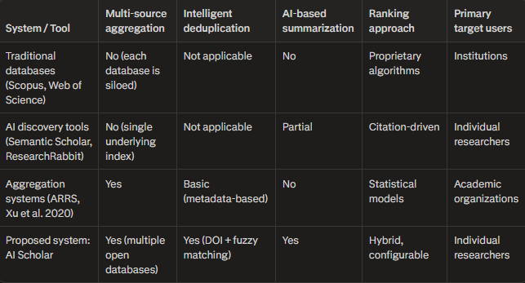
Table 1 Comparison of existing scholarly discovery tools and the proposed AI Scholar system.

Risks and Assumptions
Although the preceding sections indicate that AI Scholar is feasible in financial, operational, and technical terms, the project still depends on conditions that cannot be fully controlled. It is therefore important to identify the main risks and to make explicit the assumptions under which the system is designed and evaluated.
​
A first group of risks is associated with dependence on external services. Core functionality relies on scholarly data providers for metadata and abstracts and on large language model services for summaries. Changes in rate limits, access policies, or response formats at arXiv, Semantic Scholar, CrossRef, CORE, OpenAlex, or the AI providers could affect performance or temporarily reduce functionality. The architecture mitigates this by isolating all external integrations in a provider layer, using caching to reduce repeated calls, and implementing fallbacks where partial results are still displayed when one source is unavailable. The project assumes that public API access to these services remains broadly stable and that free or low-cost tiers continue to be sufficient for the modest usage expected during development and evaluation.
​
A second category of risk concerns data quality and consistency. Metadata returned by different providers varies in completeness and formatting, which can influence deduplication, ranking, and the usefulness of summaries. AI Scholar includes mechanisms for normalising fields, merging records that refer to the same publication, and tolerating missing values, but these mechanisms rely on the assumption that most returned metadata is at least minimally coherent. In domains where records are particularly sparse or inconsistent, additional domain-specific cleaning rules might be required, which is beyond the scope of the present implementation.
​
There are also risks related to the behaviour of large language models. Summaries and relevance explanations generated from titles and abstracts may occasionally be incomplete, imprecise, or overly confident. The system addresses this by keeping AI-generated content brief, by always presenting the original metadata and abstract alongside any summary, and by treating AI output as an aid for initial screening rather than as an authoritative source. The evaluation assumes that researchers will use these summaries to prioritise reading rather than to replace direct engagement with the underlying papers.
​
Finally, project-management risks arise from the fact that AI Scholar is developed by a single person within a fixed academic period. Unexpected personal circumstances, technical difficulties, or underestimation of implementation effort could affect the completeness of the final system. To manage this, the work plan assumes that core features—multi-source search, aggregation, deduplication, and basic ranking—are prioritised, while non-essential enhancements can be deferred or simplified if necessary. By stating these risks and assumptions explicitly, the thesis clarifies the conditions under which the results should be interpreted and provides a transparent basis for the critical discussion presented in later chapters.
​

Summary
Chapter 2 has established the context and rationale for AI Scholar by documenting the fragmentation of scholarly databases and the resulting challenges faced by researchers in conducting literature reviews. The motivation section highlighted the growth in publication volume, the dispersion of content across platforms such as arXiv, Semantic Scholar, CrossRef, CORE, and OpenAlex, and the time-consuming workflows that result from this situation. Recent improvements in open infrastructure and AI capabilities create an opportunity to address these problems through thoughtful integration rather than through new inventions.
​
The project scope defines AI Scholar as an aggregation layer that unifies searches across the selected data providers, performs automatic deduplication, applies hybrid ranking, and provides on-demand summaries, all within a simple web interface targeted at small research teams. Performance and behavioural requirements ensure responsiveness under typical academic use, while technical constraints arising from external dependencies are managed through caching, fallbacks, and a modular design. The feasibility study confirms that the project is realistic across financial, operational, technical, and schedule dimensions, and the risks and assumptions section acknowledge potential issues related to service availability and data quality while outlining mitigation strategies.
​

Overall, this chapter demonstrates that the core idea of AI Scholar—a lightweight integration of existing resources to reduce search overhead—is both necessary and achievable. The detailed scope and feasibility analysis provide a solid foundation for the analysis, design, and implementation described in the following chapters.

Analysis and Design

Introduction
Chapter 2 covered what already exists—other aggregation systems, how deduplication works, what ranking techniques researchers have tried. That established context. This chapter explains how AI Scholar actually gets built. Not what it does for users—that was Chapter 1—but how the pieces fit together internally and why specific design choices were made.
The system needs to do several things simultaneously. It queries five different databases, each with its own API and data format. It identifies duplicate papers across those results. It ranks everything using multiple signals—not just what each database thinks is relevant, but also citation counts, publication dates, and AI-generated relevance scores. It can optionally summarize papers using large language models. All of that has to happen fast enough that researchers don't get frustrated waiting, and it has to handle failures gracefully when external APIs are slow or temporarily unavailable.
Three principles guide the design. First is modularity. Each component—whether it's talking to arXiv or generating summaries with Gemini—operates independently. One can be swapped out or add a new one without breaking everything else. Second is robustness. Real-world systems face real-world problems: APIs go down, rate limits get hit, network requests time out. The system handles these situations without crashing or returning nothing. Third is transparency. Every major design decision gets documented so future developers understand why things work the way they do, and researchers can trust the system isn't doing something opaque or arbitrary.
The architecture uses a standard Model-View-Controller (MVC) pattern with clear layers. Controllers handle HTTP requests from the web interface. Services contain the actual logic—orchestrating searches, deduplicating results, ranking papers, calling AI models. Providers encapsulate everything external—the five search APIs and the language model APIs. This separation makes testing easier and lets different parts evolve independently.
Here's what the rest of this chapter covers. Section 3.2 presents the overall architecture—what the major components are and how they interact. Section 3.3 goes through each layer in detail: what the controllers do, how the service layer is organized, how providers work. Section 3.4 explains key design decisions regarding the overall architecture, component interaction, and deployment strategy. Finally, Section 3.5 summarizes the architectural decisions.
By the end of this chapter, the system's structure should be clear—not just what components exist, but why they're organized this way and how they work together.

System Architecture Overview
AI Scholar is a web application built around a layered architecture following the Model-View-Controller pattern. MVC gets used because it works. The pattern solves specific problems that matter here. One part can be modified without breaking others. Components can be tested independently. New developers understand the structure quickly because it follows conventions they already know.
The system has four main layers. The Presentation Layer is what users see and interact with—the web interface. The Controller Layer handles requests from the browser and decides what to do with them. The Service Layer does the actual work—searching databases, finding duplicates, ranking results. The Provider Layer talks to everything external—the five search APIs and the language model APIs.
This layering matters for a practical reason. When an external API changes—which happens—only the provider that talks to that API needs modification. The service layer doesn't care how providers get their data, just that they return it in the expected format. When the ranking algorithm needs improvement, that's isolated in RankingService. The presentation layer doesn't know how ranking works, it just displays whatever scores it receives.
​
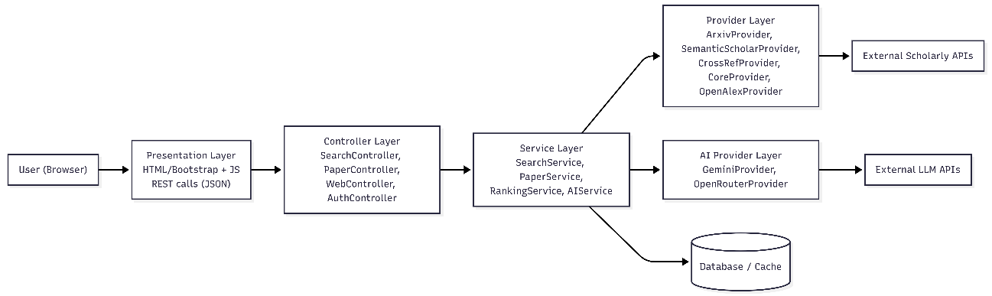
Figure 2 High-level system architecture of AI Scholar, illustrating the separation of concerns across the Presentation, Controller, Service, and Provider layers

The Four Layers
The Presentation Layer runs in the user's browser. It's built with HTML templates using Bootstrap for responsive layout. JavaScript handles dynamic updates—when someone clicks "Search," it sends a request to the backend and updates the results without reloading the page. Chart.js generates visualizations when needed, like showing how many papers came from each database. This layer communicates with the backend through REST API calls—sends JSON, receives JSON, updates the DOM.
​
The Controller Layer sits between the browser and business logic. When a request comes in, a controller receives it. SearchController handles search queries—validates the search terms, calls the appropriate services, formats results for the browser. PaperController manages operations on individual papers, like fetching full metadata or getting citation information. WebController serves the HTML pages—home page, search results page, about page. AuthController handles user login, session management, authentication tokens. Controllers stay thin—they don't contain business logic, just request handling and response formatting.
​
The Service Layer is where actual work happens. SearchService orchestrates the whole search process. When it receives a query, it distributes it to all five search providers in parallel. It collects what comes back, passes everything to PaperService for deduplication, sends deduplicated results to RankingService for scoring, optionally calls AIService to generate summaries. Each service focuses on one job. AIService manages all interactions with language models—handles API keys, rate limiting, fallback between providers, prompt formatting, response parsing. PaperService deals with paper metadata—normalizing fields across different sources, extracting authors and publication dates, identifying duplicates. RankingService implements the hybrid ranking algorithm that combines citation counts, publication dates, database confidence scores, AI relevance assessments. Services don't know anything about HTTP or JSON formatting—they just implement business logic.
​
The Provider Layer encapsulates everything external. Search providers—ArxivProvider, SemanticScholarProvider, CrossRefProvider, CoreProvider, OpenAlexProvider—each implement a common SearchProvider interface. That interface defines one method: search(query, limit). Each provider translates that into whatever its specific API expects, makes the HTTP request, parses the response, returns results in a normalized format. If arXiv's API returns XML while Semantic Scholar returns JSON, that's the provider's problem. The service layer just calls search() and gets back a list of Paper objects. AI providers work the same way. GeminiProvider and OpenRouterProvider both implement an AIProvider interface with methods like generate_summary(text) and score_relevance(query, abstract). Services don't care which AI model is being used—they just call the interface methods.
​
This provider abstraction solves real problems. When an API changes its response format—which happened with Semantic Scholar during development—one provider file gets updated. When an API goes down or hits rate limits, fallback logic in the service tries providers in sequence. When adding a new database, a new provider class gets written that implements the SearchProvider interface, gets registered with SearchService, and everything else works without changes.

Component Interaction Workflow
"A concrete example, illustrated in Figure 3.2, shows how these layers actually work together. Say someone searches for 'machine learning in healthcare.The browser sends a POST request to /api/search with that query string. WebController catches it and routes to SearchController.
SearchController does basic validation first. Is the query empty? Did the user select specific databases or all five? Are there filters like publication year ranges? Once that checks out, it calls SearchService.search(query, options).
SearchService looks at which databases are enabled. If all five, it creates five separate tasks. These launch in parallel using Python's async features. ArxivProvider hits the arXiv API. SemanticScholarProvider queries Semantic Scholar. CoreProvider, CrossRefProvider, and OpenAlexProvider do the same for their respective services.
Network speed varies, so results don't arrive simultaneously. arXiv might respond in 0.3 seconds. CORE could take 1.2 seconds. SearchService waits for all of them but times out after 5 seconds—if something's really slow or down, the search doesn't hang forever.
Providers return normalized Paper objects—same structure regardless of source. Each has title, authors, abstract, publication year, DOI if available, URLs. SearchService collects them all. At this point there might be 200 papers, but plenty are duplicates because the same paper appears in multiple databases.
It passes that list to PaperService.deduplicate(papers). The deduplication algorithm (detailed in Section 3.4) compares papers using DOI matches, title similarity, author overlap. When duplicates get identified, PaperService merges their metadata intelligently. One source might have citation count, another has complete author affiliations, a third has the full abstract. The merged version keeps the best information from each. That typically drops 200 papers down to 150 unique ones.
Next step is RankingService.rank(papers, query). This scores each paper using the hybrid algorithm—combines citation count, publication recency, which database returned it, and optionally AI-generated relevance scores. Papers get sorted by final score.
If AI summarization is on, SearchService grabs the top 20 papers and calls AIService.generate_summaries(papers). This runs in the background—asynchronously—so the user doesn't wait. Summaries get cached as they finish generating.

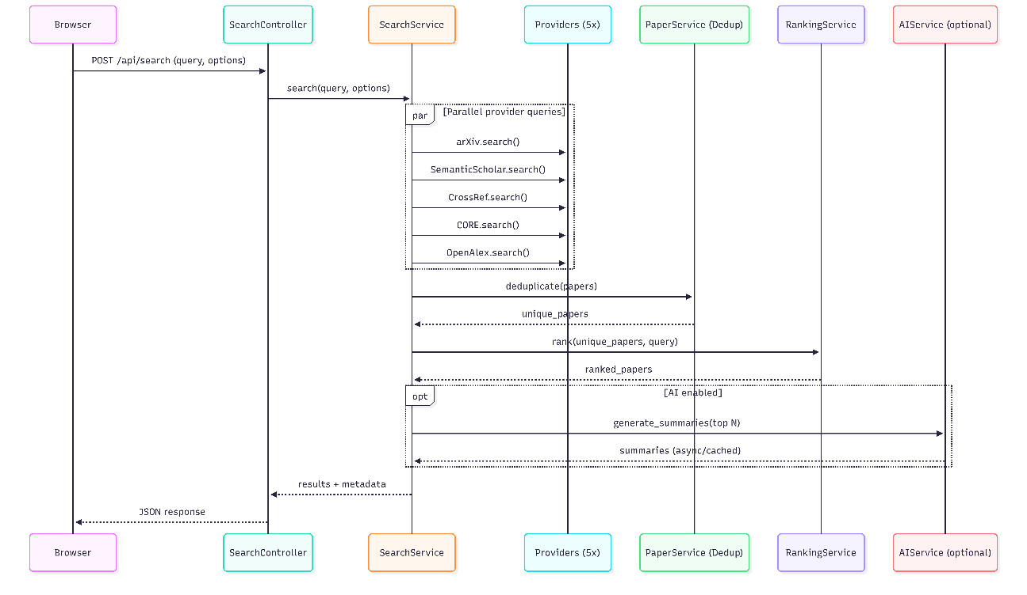
Figure 3 Sequence diagram detailing the component interaction workflow during a user search request, highlighting the parallel execution of external API calls and the asynchronous generation of AI summaries
SearchService returns the ranked, deduplicated results to SearchController. SearchController formats everything as JSON—papers with scores, metadata, summaries if available—and sends it back to the browser. JavaScript parses that JSON and updates the page. Papers appear in ranked order with titles, authors, abstracts, buttons for more details.
User clicks "View Paper" on something interesting. That fires a GET request to /api/paper/{id}. PaperController receives it, validates the ID exists, calls PaperService.get_paper_details(id) to fetch full metadata and citation info. Returns that as JSON. The frontend renders it—usually a modal or separate detail view.
Why does this layered approach matter? Each component only talks to the one below it. Browser → Controllers → Services → Providers. Modifying one layer doesn't break others. Testing gets easier too. Services can run without a web server. Providers can run without the full application. The ranking algorithm can get tested with fake data. During development this separation proved essential—debugging one component without running everything else saved substantial time.

Architectural Design Rationale
Several specific choices in this architecture require explanation. First, why run search providers in parallel rather than sequentially? Network latency. If five APIs are queried sequentially and each takes one second, that's five seconds minimum. Querying in parallel means total time equals the slowest API, typically 1-2 seconds. Users notice the difference.
Second, why normalize everything to a common Paper format immediately in providers rather than keeping raw API responses? Because downstream components—deduplication, ranking, summarization—need to work with consistent data structures. If each service had to handle five different formats, the code would be unmaintainable. Normalizing at the provider boundary keeps complexity isolated.
Third, why implement AI as a separate service rather than embedding it in SearchService? Because AI integration is optional and expensive. Not every search needs summaries. Rate limits on API calls mean summaries can't be generated for every result. Separating AIService lets SearchService work without it, and enables independent testing and modification of AI features.
Fourth, why cache at the service layer rather than at the provider layer? Because deduplication and ranking can produce different results even for the same raw provider data depending on the query context. Caching too early means missing those optimizations. Caching final results after all processing means users get exactly what they saw before if they repeat a search.
The architecture isn't theoretical. It emerged from actually building the system and running into problems. The current structure reflects what worked when APIs went down, when ranking algorithms changed, when new databases got added. It's designed for modification because research infrastructure keeps changing.

Component Design
This section goes into detail about what each layer actually does and why it's designed that way. Understanding these pieces matters if the system needs modification or debugging later.

Controller Layer
Controllers handle HTTP requests. Their job is straightforward: receive a request, validate it, call the appropriate service, return a response. They don't implement business logic. This isn't arbitrary—it's a deliberate design choice. If business logic gets embedded in controllers, logic can't be testedc without spinning up the entire web server. It also can't be reused it in other contexts like command-line scripts or background jobs. So controllers stay thin by design. SearchController is the main entry point for search requests. It exposes /api/search as a POST endpoint. When a request comes in, the controller does basic validation. Is the query string empty? Which databases did the user select? Are there any filters like publication year or author name? Once the inputs check out, it calls SearchService.search() with those parameters. The service does the actual work. When results come back, SearchController wraps them in JSON with pagination information—how many total results, which page this is, how many results per page. If something goes wrong—malformed request, server error—the controller returns an appropriate status code (400 for bad requests, 500 for server errors) and an error message. PaperController handles individual paper operations. The main endpoint is /api/paper/{id}, which returns full details about a specific paper—abstract, authors with affiliations, citation count, related papers unless having them. There's also /api/paper/{id}/cite which generates formatted citations in different styles (APA, MLA, Chicago). The controller validates the paper ID, calls PaperService.get_paper_details(id), and returns what it gets back. If the paper doesn't exist, it returns 404. WebController serves HTML pages rather than JSON. It handles routes like / for the homepage, /search for the search interface, /about for documentation. Each route loads a template, passes in whatever data that template needs, returns rendered HTML. This controller is simpler than the others because most of the dynamic behavior happens client-side in JavaScript. AuthController manages authentication and sessions. It provides /api/auth/login for authentication, /api/auth/logout for ending sessions, and /api/auth/verify for checking whether a session is still valid. Authentication is optional—guests can search without logging in. Authenticated users get additional features like saved searches and history. The implementation uses JSON Web Tokens (JWT). Each token contains user information and is cryptographically signed, which lets the server verify it without querying the database every time. ​ The controller pattern keeps the codebase organized. Every HTTP endpoint corresponds to one controller method. Controllers are short—usually 20-30 lines that validate input, call a service, format the response. This makes them easy to test because there's not much logic to verify. It's also easy to see what API endpoints exist just by looking at the controller classes.

Service Layer
Service components implement the principal business logic of the system. In contrast to controllers, which are directly bound to the HTTP layer, services are designed as independent Python classes that can be executed in multiple contexts. They may be invoked within web requests, from command-line interfaces, by background processing tasks, or during unit testing. This separation of concerns strengthens modularity and enhances the overall adaptability of the architecture.
The SearchService is responsible for managing the complete search procedure. Its central method, search(query, options), receives a query string together with optional configuration parameters, including the databases to be queried, filtering constraints for the results, and an option to enable AI-driven summarization. The method proceeds through a sequence of coordinated steps, each addressing a specific stage of the retrieval and processing workflow, thereby structuring the search operation into clearly defined phases.
First, it figures out which search providers to query based on options.databases. If the user picked specific ones, use those. Otherwise query all five. Then it creates asynchronous tasks for each provider using Python's asyncio. This runs queries in parallel instead of one after another. Each task calls the provider's search() method.
The service waits for all tasks to complete, or times out after 5 seconds, whichever comes first. If a provider is slow, the whole search doesn't hang. Results from all providers get collected into one list. At this point there are duplicates—the same paper might appear from multiple databases.
The subsequent stage involves invoking PaperService.deduplicate() in order to detect and consolidate duplicate records within the retrieved dataset. Once redundancy has been addressed, RankingService.rank() is applied to evaluate and order the resulting set according to predefined scoring criteria.
When AI-based summarization is activated, the system calls AIService.generate_summaries() for the top ranked items. This operation is executed asynchronously, allowing the primary search results to be returned without delay while summaries are generated in the background.
The process concludes with the return of the ranked results, accompanied by metadata indicating the distribution of records across the queried databases.
SearchService also implements caching. If the same query gets searched twice within a short period, it returns cached results instead of hitting APIs again. Cache keys are based on the query string and selected options. Cache entries expire after 15 minutes because search results can change as new papers get indexed.
AIService manages all interactions with language models. It has several methods: generate_summary(text) creates a concise summary of a paper abstract, score_relevance(query, abstract) returns a 0-1 score indicating how well a paper matches the query, extract_keywords(text) identifies important terms.
The challenge with AI services is reliability. Language model APIs have rate limits, sometimes go down, occasionally return errors. AIService handles this through a provider fallback mechanism. It tries GeminiProvider first (Google's Gemini API). If that fails due to rate limiting or network issues, it falls back to OpenRouterProvider which aggregates multiple models. If both fail, it returns gracefully without crashing the search—summaries just won't be available for that query.
​
AIService also implements prompt engineering. When generating summaries, it doesn't just send the abstract to the model. It constructs a specific prompt: "Summarize the following research paper abstract in 2-3 sentences, focusing on the main contribution and findings. Abstract: {text}". This structured prompting produces more consistent results than raw text.
PaperService handles paper metadata operations. Its main responsibility is deduplication, implemented in deduplicate(papers). This method takes a list of papers from multiple sources and figures out which ones are duplicates. The algorithm uses multiple signals—exact DOI matches, title similarity using Levenshtein distance (if titles are 90%+ similar and authors overlap, they're likely the same paper even without matching DOIs), arXiv ID matches since arXiv papers have unique identifiers that persist even when published elsewhere.
When duplicates get identified, PaperService merges their metadata intelligently. It keeps the most complete information from each source. If one source has citation count and another has a full author list, the merged paper gets both. This produces richer metadata than any single source provides.
PaperService also implements get_paper_details(id) which retrieves full information about a specific paper, potentially querying multiple providers to enrich metadata. And get_related_papers(id) which uses citation networks to find similar work.
RankingService scores papers using a hybrid algorithm. The method rank(papers, query) takes a list of deduplicated papers and the original search query. It calculates a score for each paper based on multiple factors.
Citation count matters—papers with more citations score higher. The scoring uses logarithmic scaling because the difference between 10 and 20 citations matters more than between 1000 and 1010. Recency matters too. A paper from 2024 scores higher than one from 2015, all else equal. The boost decays exponentially with age. Source confidence is a factor—results from Semantic Scholar get higher weights than results from sources with less quality control. If AI scoring is enabled, AIService.score_relevance() contributes to the final score.
Each factor gets a weight, and the final score is a weighted sum. Weights are configurable through a JSON file so ranking can be tuned without changing code. The default weights were determined empirically by testing with actual queries and seeing what produced useful result ordering.
The service layer design follows established patterns. Services are stateless—they don't store data between method calls. They can be called from multiple threads safely. They handle errors by returning error objects rather than crashing. This makes the system robust and testable.

Provider Layer
Providers encapsulate external dependencies. Every interaction with something outside the application—whether that's arXiv's API or Google's Gemini model—goes through a provider. This abstraction has practical benefits. When an external API changes, one provider file gets modified. When adding a new database, a new provider gets written without touching service code.​
ArxivProvider queries the arXiv API which returns XML responses. The provider constructs the appropriate query URL, makes an HTTP GET request, parses the XML response, extracts relevant fields, creates Paper objects. arXiv returns preprints, so papers typically don't have DOIs or citation counts. The provider normalizes fields—if arXiv returns publication date as "2024-01-15", it converts that to a datetime object that other components expect.
SemanticScholarProvider uses Semantic Scholar's REST API which returns JSON. This provider has access to richer metadata—citation counts, influential citation counts, paper fields of study. It queries the /graph/v1/paper/search endpoint with the query string, parses the JSON response, creates Paper objects. Semantic Scholar has rate limits (100 requests per 5 minutes for free tier), so the provider implements rate limiting logic to avoid getting blocked.
CrossRefProvider queries CrossRef's public API for publication metadata. CrossRef has authoritative DOI information and publisher data. The provider searches using the /works endpoint, which returns extensive metadata but can be slow. Results get normalized to the common Paper format.
CoreProvider accesses CORE's aggregation of open-access papers from institutional repositories. The API requires an API key (free but requires registration). The provider constructs queries to CORE's search endpoint, handles pagination because CORE returns results in batches of 10, normalizes the response format which differs from other providers.
OpenAlexProvider queries OpenAlex which has extensive coverage and high-quality metadata about authors, institutions, citation networks. The API is free and doesn't require authentication. The provider queries the /works endpoint with filters, parses the JSON response which uses a different schema from other providers, normalizes everything to Paper objects.
Each provider handles errors differently because each API has different failure modes. arXiv rarely goes down but sometimes returns malformed XML. Semantic Scholar hits rate limits. CORE can be slow. OpenAlex occasionally times out. Providers catch these errors, log them, return empty result sets rather than crashing. This way if one database is temporarily unavailable, the other four still work.
GeminiProvider uses Google's Gemini API. It handles authentication using API keys stored in environment variables, constructs requests to the Gemini endpoints, parses responses, handles errors like rate limiting or quota exceeded.
OpenRouterProvider aggregates multiple language models—GPT-4, Claude, Llama, others—through a single API. It serves as a fallback when Gemini is unavailable. The provider handles OpenRouter's unified API format and translates errors from the underlying models.
The provider pattern makes testing easier. Mock providers can be written that return hardcoded data for unit tests. The service layer can be tested without making actual API calls. And providers can be swapped entirely—if a better database comes along, write a new provider and register it without changing SearchService.

Data Models
Data models define the structure of information throughout the system. AI Scholar uses four main models: User, Search, Paper, and SearchResult.
User represents authenticated users. Fields include username, email, hashed password (never stored in plain text), registration date, preferences like default databases to search. Users can save searches and view search history.
Search represents a search query and its metadata. Fields include the query string, selected databases, filters applied, timestamp when the search was executed, user ID if authenticated, whether AI features were enabled. Searches get stored in the database so users can view their history.
Paper is the core data model representing a research paper. It has fields normalized across all providers: title, authors (list of author objects with names and affiliations), abstract, publication year, DOI, URLs (to PDF, publisher page, arXiv page), citation count, source database, keywords, a unique identifier generated by hashing multiple fields to enable deduplication.
Paper objects are immutable after creation—if metadata needs updating, a new Paper object gets created. This simplifies concurrency and caching.
SearchResult wraps a Paper with search-specific metadata: the relevance score assigned by RankingService, which databases returned this paper, AI-generated summary if available, position in the ranked result list. SearchResult separates intrinsic paper properties from search-context properties.
Models use Python dataclasses which provide automatic __init__, __repr__, and comparison methods. This reduces boilerplate code and makes models easy to work with. Models also implement validation—for example, publication year must be between 1900 and the current year, citation count must be non-negative.
The component design reflects what actually worked during development. Controllers started more complex but got simplified when it became clear they should only handle HTTP concerns. Services started smaller but accumulated responsibility as shared logic got extracted from controllers. Providers used to return raw API responses but that made service code messy, so normalization moved into providers. These design choices emerged from building the system and refactoring as problems became apparent.
​

System Architecture and Design
The system architecture describes how all the components fit together and how data flows through the system. AI Scholar follows a layered architecture based on the Model-View-Controller (MVC) pattern, adapted for a web application that integrates multiple external services.

Overall Architecture
The system is built in 4 layers. At the top is the Presentation Layer the web interface and REST API controllers. This is what users interact with. It displays search results, renders pages, handles API requests.
Below that is the Service Layer where business logic lives. SearchService, AIService, PaperService, RankingService—all the core functionality sits here. This layer doesn't care about HTTP or web stuff. It's just Python classes with methods that do the actual work.
The Provider Layer handles external communication. Every call to arXiv's API, every query to Semantic Scholar, every request to language models goes through a provider. Each provider takes whatever format the external service uses and converts it to AI Scholar's internal data format.
At the bottom is the Data Layer—the database and data models. PostgreSQL in production, SQLite for local development. This is where user accounts get stored, search history gets saved, results get cached.
Data flows top to bottom and back up again. User submits a search. Request hits SearchController. Controller validates the input, calls SearchService. SearchService does the coordination asks each provider to query its database, waits for responses, calls PaperService to remove duplicates, calls RankingService to score and sort everything. Results come back up through SearchService to SearchController, which wraps them in JSON and sends to the browser.
The architecture follows Model-View-Controller adapted for web applications. Controllers handle HTTP requests. Services contain the business logic—that's the model layer. Views are split between server-side templates for HTML pages and client-side JavaScript for dynamic behavior. Each piece has one job.
Communication happens through method calls going down the stack. Controllers import services and call their methods. Services import providers and call their methods. The dependency only goes one direction—providers don't know about services; services don't know about controllers. This prevents circular dependencies and keeps things manageable.
Testing gets easier with this structure. Each layer can be tested separately. Controllers get tested by making HTTP requests and checking responses. Services get tested by calling methods with mock data. Providers get tested by mocking external APIs. Then integration tests verify the layers work together.
The design pattern is a standard layered architecture that's been used in web applications for years. Layers are clearly separated. Dependencies point one direction. Each component has a specific job. When something breaks, it's usually obvious which layer has the problem.

Component Interaction
Components communicate through well-defined interfaces. Controllers talk to services. Services talk to providers and sometimes to other services. Providers talk to external APIs. Dependencies go one direction—down the stack. This keeps things clean.
When SearchService needs to query databases, it doesn't just loop through providers one by one. It uses Python's asyncio to create asynchronous tasks. Each task calls one provider's search() method. All five tasks run at the same time instead of waiting for each to finish. SearchService waits for all tasks to complete, or times out after 5 seconds if something's slow. Results from all providers get collected into one list.
Here's what the interaction looks like. SearchController receives a request and calls SearchService.search(query, options). SearchService looks at which databases are selected and creates a task for each—ArxivProvider.search(query), SemanticScholarProvider.search(query), and so on. These execute in parallel. As each provider finishes, SearchService collects the results.
Once all providers respond (or the timeout hits), SearchService has a list of papers from multiple sources. Many are duplicates—same paper from different databases. It calls PaperService.deduplicate(papers) which returns the cleaned list. Then it calls RankingService.rank(papers, query) to score each paper and sort by relevance. If AI features are enabled, it calls AIService.generate_summaries(papers) for the top results. This happens asynchronously so the method returns immediately while summaries generate in the background.
Error handling works in layers. Providers catch exceptions from external APIs and return empty result sets instead of letting errors propagate up. If arXiv times out, ArxivProvider logs the error and returns an empty list. SearchService gets results from the other four providers and continues. Services check for problems and handle them gracefully. If every single provider fails, SearchService returns an empty result set with metadata explaining what went wrong. Controllers catch exceptions from services and return proper HTTP error codes—400 for client problems, 500 for server issues—with messages that make sense. This means one database failing doesn't crash the whole search.
Services communicate through direct method calls. When SearchService needs deduplication, it instantiates PaperService and calls deduplicate(). When RankingService needs AI relevance scores, it creates an AIService instance and calls score_relevance(). Services don't keep permanent references to each other—they create instances when needed. Keeps coupling loose.
Caching happens in SearchService. It maintains an in-memory cache of recent searches, keyed by query string and selected options. Before querying providers, it checks the cache. If there's a matching entry that hasn't expired, it returns cached results immediately without hitting any APIs. Cache entries expire after 15 minutes because search results change as databases index new papers. The cache is just a Python dictionary with timestamps. It reduces API load and makes repeat searches fast.
Data flows in a predictable sequence. User input comes through controllers. Controllers validate and pass to services. Services coordinate work across providers and other services. Providers fetch data from external sources. Results flow back up—providers return to services, services process and return to controllers, controllers format and send to users. Each layer adds its piece without needing to know how other layers work internally.

Deployment Architecture
The deployment architecture, shown in Figure 3.3, reflects the system's reliance on external services and its lightweight internal structure.
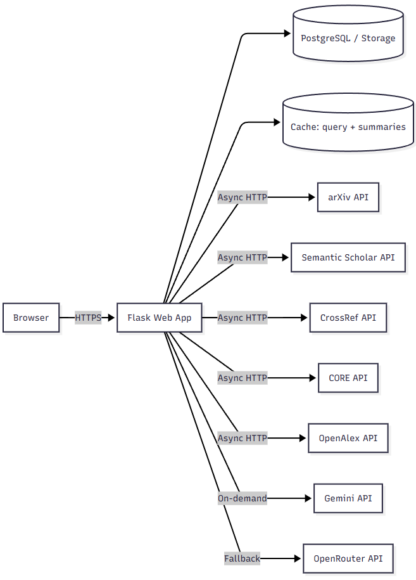
Figure 4 Deployment architecture of AI Scholar, showing the central Flask application routing traffic between the user browser, local database/cache, and external scholarly and AI APIs.

The deployment setup is built around practical constraints. During development, the system runs locally with Flask's built-in server. For production, the application is deployed on PythonAnywhere, a hosting platform designed for Python web applications.
Choosing this specific domain was the optimal choice for the needs of this thesis. PythonAnywhere handles infrastructure so development can focus on functionality.
Production deployment uses Gunicorn as the Web Server Gateway Interface (WSGI) server. Gunicorn handles multiple concurrent requests better than Flask's development server. It sits between Nginx (the web server) and the Flask application. Nginx receives incoming HTTP requests, serves static files directly, and forwards dynamic requests to Gunicorn. This separation is common in Python web deployments. Static files don't need to go through Python code, which is faster.
Database configuration changes depending on the environment. Development uses SQLite because it needs no separate database server—everything lives in one file. Someone cloning the repository just installs dependencies and runs the app. No database setup required. Production uses PostgreSQL, which handles concurrent users better and provides proper transaction support. The application code works with both through SQLAlchemy's Object Relational Mapping(ORM), so switching databases means changing one configuration line.
Static assets— Cascading Style Sheets (CSS) files, JavaScript, images—get served by Nginx without involving Flask. This is more efficient than having Python handle static content. The files are versioned and cached appropriately, reducing bandwidth and improving load times.
External API communication uses HTTPS for all five scholarly databases and the AI providers. The system doesn't assume networks are always reliable because they're not. Each provider implements retry logic with exponential backoff. If a request to Semantic Scholar fails, the provider waits briefly and tries again. After three attempts, it returns an empty result set and logs the failure. This handles temporary network issues without breaking the entire search when one database has problems.
The deployment is stateless by design. Authentication uses JSON Web Tokens that contain all session information. The server doesn't store session data anywhere. This means any request can be handled by any server instance, which makes scaling simpler. Currently there's one instance, but adding more wouldn't require major changes.
Configuration follows twelve-factor app principles. API keys, database credentials, and environment-specific settings are stored as environment variables, not hardcoded. Development, staging, and production use separate configuration files. This prevents mistakes like using production credentials during development.
The application includes a /health endpoint that returns status information—database connectivity, external API availability, system resources. Monitoring systems can query this to detect problems before users notice them. If the database becomes unreachable or too many external APIs fail, alerts trigger.
Logging captures comprehensive information. Every search query gets logged with timestamp, selected databases, and result count. External API errors get logged with context—which provider failed, the error message, retry attempts. Slow operations get performance metrics logged. During development, these logs helped identify bottlenecks and debug intermittent problems. In production, they show usage patterns and where failures occur.
Deployment automation is straightforward. Code gets pushed to Git. A post-commit hook on PythonAnywhere pulls the latest version and restarts the application. Database migrations run automatically through Flask-Migrate, which handles schema changes without manual Structured Query Language (SQL). This isn't as elaborate as full Continuous Integration and Continuous Delivery (CI/CD) pipelines, but it's reliable for a research system.
The architecture could support different deployment scenarios. The application could run on institutional servers within university networks, giving researchers access while keeping data internal. It could be containerized with Docker for cloud platforms like Amazon Web Services (AWS) or Google Cloud Platform (GCP). The stateless design and external configuration make these transitions manageable.

Summary
This chapter documented the analysis and design of AI Scholar. The work began with requirements elicitation—talking to researchers about their actual search workflows and what problems they face. The same complaints came up consistently. Searching multiple databases separately wastes time. The same paper appears multiple times across different platforms with slightly different metadata. Reading dozens of abstracts to figure out which papers are actually relevant is tedious. These real frustrations shaped the functional and non-functional requirements.
Usage scenarios illustrated different ways researchers would interact with the system. A graduate student doing their first literature review has different needs than an experienced professor tracking new publications in their field. Someone conducting a systematic review needs comprehensive coverage across all databases. These scenarios kept design decisions grounded in how people would actually use the system rather than theoretical possibilities.
Database modeling established the core data structures. Four entities make up the data model. User stores authentication information and preferences. Search records query history. Paper contains normalized publication metadata from all sources. SearchResult wraps papers with search-specific data like relevance scores and AI summaries. The schema balances normalization with practical query patterns.
Component design in Section 3.3 broke down the layered architecture. Controllers process HTTP requests—validate input, call services, return formatted responses. No business logic in controllers. Services implement actual functionality. SearchService queries multiple providers simultaneously, then coordinates deduplication and ranking. AIService handles language model calls with fallback when providers fail. PaperService manages metadata operations and intelligently merges duplicates. RankingService scores papers based on multiple factors—citation counts, publication date, source reliability, AI-determined relevance. Providers wrap external APIs. Each search provider converts its API response format into standard Paper objects. Each AI provider implements a common interface. When Semantic Scholar reorganized their API during development, only SemanticScholarProvider needed changes. Everything else kept working.
System architecture showed how these pieces connect. Four layers sit on top of each other: presentation, controller, service, provider. Data flows predictably through them. Requests arrive at controllers. Services coordinate work. Providers fetch from external sources. Results flow back up. Asynchronous execution runs provider queries in parallel, so searches complete in one or two seconds despite hitting five APIs. Error handling at each layer contains failures—one database timing out doesn't kill the whole search.
Deployment architecture assumes realistic infrastructure constraints. Production deployment uses platforms like PythonAnywhere with Gunicorn and PostgreSQL. Development runs locally with Flask's server and SQLite. The stateless design with JWT authentication means horizontal scaling is straightforward if needed. Configuration follows twelve-factor principles—API keys and credentials live in environment variables, not code.
Design rationale explained why specific approaches were chosen. Running provider calls in parallel came from performance requirements. Sequential execution would be too slow. Normalizing data inside providers instead of services eliminated duplication across the codebase. The provider abstraction meant external API changes stayed isolated. Error handling at each layer prevented cascading failures. Most of these decisions came from encountering actual problems during development, not from perfect upfront planning.
Known limitations exist. Caching is deliberately simple. Ranking algorithm weights came from empirical tuning with limited testing rather than rigorous optimization. These represent trade-offs between development time and theoretical perfection. The system works adequately for its purpose even with these limitations.
The next chapter describes implementation—turning this design into working code. What technologies got used, how development proceeded, what problems came up, how testing verified the system actually works.

Implementation and Testing

Introduction
This chapter describes how the design documented in Chapter 3 was turned into working code. The previous chapter explained what the system should do and how components should be organized. This chapter covers the implementation, which technologies were used, the code structure, the possible problems occurred, and how testing verified everything works.
The implementation process wasn't perfectly linear. Design decisions from Chapter 3 guided initial development, but some details changed as problems became apparent. For example, the caching mechanism started more complex but got simplified when the added complexity didn't provide enough benefit. The ranking algorithm weights got adjusted multiple times based on testing with actual queries. These changes are documented here because they reflect how real software development works—iteration and refinement based on what actually functions well.
Section 4.2 describes the development environment. What programming language and framework were chosen? What tools were used for writing code, managing versions, and debugging? What external APIs does the system depend on? Understanding the development environment matters because it affects what's possible to implement and how long implementation takes.
Section 4.3 covers implementation details. How were controllers, services, and providers actually coded. What specific algorithms handle deduplication and ranking. How was the frontend built How does database interaction work? This section connects the abstract design from Chapter 3 to concrete code.
Section 4.4 describes testing. How was the system verified to work correctly. What types of testing were performed. What issues were discovered and how were they addressed. What known limitations remain. Testing matters because it provides confidence that the system actually does what it's supposed to do.
By the end of this chapter, the path from design to working system should be clear. Someone reading this should understand not just what was built, but how it was built and why specific implementation choices were made.

Implementation Issues / Development Environment

Programming Language and Framework
The system is implemented in Python 3.11. Python was chosen for several practical reasons. First, it has strong support for asynchronous Input/Output (I/O) through the asyncio library, which is essential for querying multiple APIs simultaneously. Second, Python has mature libraries for HTTP requests (requests), JSON parsing (built-in), and data manipulation (pandas for result processing). Third, most machine learning and natural language processing libraries are Python-first—accessing language models through APIs is straightforward with libraries like openai and google-generativeai.
Flask serves as the web framework. Flask was chosen over Django because it's lightweight and doesn't impose much structure. Django includes an ORM, admin interface, authentication system, and many other components out of the box. For AI Scholar, that's unnecessary overhead. The system needs a way to route HTTP requests to functions and render templates—Flask does exactly that without extra components. Flask's minimalism also makes the codebase easier to understand. Someone reading the code can see what's actually implemented rather than guessing which parts are Flask defaults.

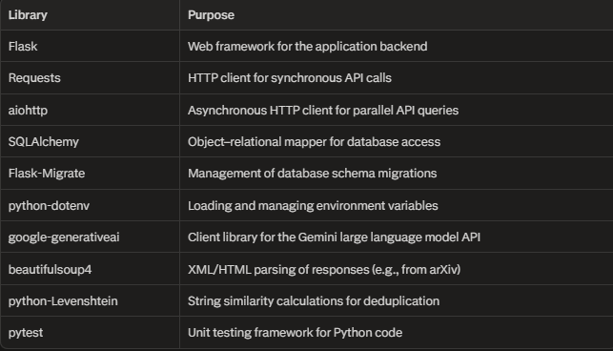
Table 2 Python Attributes

Programming Language and Framework
Development used Visual Studio Code(VS code) as the primary Integrated Development Environment (IDE). VS Code has good Python support through extensions—syntax highlighting, debugging, integrated terminal, Git integration. The Python extension provides IntelliSense for autocomplete and type hints, which catches errors before running code. Version control uses Git with GitHub for remote hosting. The repository structure follows standard Python project layout:

Table 3 Ai Scolar Project Layout
ai-scholar/
├── app/
│ ├── controllers/
│ ├── services/
│ ├── providers/
│ ├── models/
│ └── templates/
├── tests/
├── config/
├── requirements.txt
└── README.md

Each component type occupies a specific directory. Controllers live in app/controllers/, services in app/services/, providers in app/providers/. Modifying search functionality requires navigating to services/SearchService.py. To update an API integration, it means locating the relevant provider file in app/providers/. This organizational structure evolved from practical necessity rather than upfront planning. During early development, when the codebase was small, a simpler file structure would have sufficed. As additional code accumulated, maintaining clear boundaries between component types became essential for preventing circular dependencies and maintaining code clarity.
Dependency management uses pip with virtual environments. All required libraries are listed in requirements.txt with version numbers specified. Setting up a development environment involves three steps: creating a virtual environment, activating it, and installing dependencies. This approach addresses a common Python development challenge dependency conflict between libraries requiring different versions of shared dependencies. Version pinning in requirements.txt prevents such conflicts. During development, when new libraries were introduced, they were immediately added to requirements.txt to ensure subsequent developers would receive the complete dependency set without manual intervention.
Database inspection tools differed based on the deployment environment. Local development with SQLite utilized Database (DB) Browser for SQLite, which provides a graphical interface for examining tables, browsing data, and executing manual queries. This capability proved valuable during debugging sessions. When search persistence exhibited unexpected behaviour, direct database inspection revealed discrepancies between expected and actual stored data. Production deployment uses PostgreSQL, managed through pgAdmin. This tool offers comparable inspection features while additionally supporting database administration tasks such as user permission management and backup configuration.
API endpoint testing during development relied on Postman rather than writing test scripts or constructing curl commands for each verification. Postman allows configuration of HTTP requests—specifying endpoint URLs, parameters, and headers which can then be executed repeatedly as needed. Testing the /api/search endpoint with various query parameters involved configuring a request in Postman and executing it. When controllers returned unexpected status codes or malformed responses, Postman facilitated isolating whether issues originated in controller logic or in request construction. The collection of saved requests also served as informal API documentation. New developers could examine the Postman collection to understand available endpoints and their expected input parameters.

External APIs and Services
AI Scholar depends on seven external APIs. Five provide scholarly data, two enable AI features. Each has distinct characteristics that shaped how the system was implemented.
arXiv API serves preprints in physics, mathematics, computer science, and related fields. Requests use HTTP GET with parameters in the URL. Responses come back as Atom XML, which needs parsing before use. No authentication is needed. Rate limiting kicks in at roughly one request every three seconds—go faster and HTTP 503 errors appear. The documentation explains basic usage reasonably well, but parsing the XML took more work than expected. Author information, for instance, sits nested several levels deep in the XML structure. Extracting names and affiliations meant traversing multiple elements rather than just reading a single field.
Semantic Scholar API returns paper metadata, citation counts, influential citation metrics, and recommendations based on semantic similarity. It follows standard REST patterns with JSON responses. The free tier allows 100 requests per five minutes. Authentication happens through an API key in the request headers. Documentation is thorough with good examples. The main challenge was staying under the rate limit. During development, repeatedly testing search functionality hit the limit frequently. This forced implementation of exponential backoff retry logic and local caching to avoid making the same request multiple times.
CrossRef API supplies DOI metadata and publication details from academic publishers. It's publicly accessible without authentication. Responses use JSON. The service is reliable but sometimes slow—requests can take two or three seconds. CrossRef supports complex query syntax, but AI Scholar only uses basic keyword searches. Coverage is strong for formally published papers but misses preprints and grey literature, which is why other data sources are necessary.
CORE API pulls together open-access papers from thousands of institutional repositories. Responses are JSON. Results come in batches of ten, so getting comprehensive results requires pagination. The documentation handles common cases adequately. Some situations—like repositories with inconsistent metadata—aren't well documented and required trial and error to figure out. CORE matters because it indexes institutional repositories that commercial databases miss.
OpenAlex API offers extensive scholarly metadata: publications, citations, authors, institutions, research topics. Free access, no authentication needed. JSON responses. The API is well-designed with robust filtering and sorting. Documentation includes many examples. The response structure is more complex than other APIs. Author, institution, and concept data come as nested objects that need careful parsing. OpenAlex proved especially useful because it has citation data and detailed author information that some other sources lack.
Google Gemini API gives access to Google's generative models for text generation. Requires an API key from Google Cloud Console. AI Scholar uses it for paper summaries and computing how well papers match queries. The free tier includes 60 requests per minute, which handled development and initial testing fine. Using the API is straightforward—send a prompt, get generated text back. The challenge was prompt engineering. Early attempts produced summaries with inconsistent structure. Getting reliable output required refining prompts to explicitly specify what format was wanted.
OpenRouter API consolidates multiple language models—GPT-5, Claude, Llama, others—behind one interface. Needs an API key and costs money, with pricing depending on which model is used. AI Scholar treats it as a backup when Gemini is down or rate-limited. The unified format makes switching models easy. Changing from GPT-5 to Claude means updating one configuration value instead of rewriting code. During development, this made it practical to test which models generated the most useful summaries.
These API characteristics directly influenced provider implementation. Rate limits determined retry behavior and caching strategies. Response formats shaped parsing code. Reliability differences affected error handling logic. The provider code documents which behaviors come from external API constraints versus internal design decisions.

Hardware Requirements
Development happened on a laptop with reasonable but not exceptional specs: Intel Core i5 with four cores, 16 GB RAM, 256 GB SSD, running both Windows 11 and Ubuntu 22.04 as a dual-boot setup. These specs worked well for development. The performance bottleneck isn't processing power—it's waiting for external APIs to respond. A slower machine would work nearly as well because most time gets spent waiting on network requests rather than doing local computation.
Production deployment uses PythonAnywhere's shared hosting. The allocated resources are minimal: one shared CPU core, 512 MB RAM, 1 GB disk space, Linux environment. Despite the limited resources, this configuration handles the workload adequately. The application spends most of its time waiting for API responses rather than processing data, so it's I/O-bound instead of CPU-bound. RAM is the tightest constraint. With 512 MB, there isn't much space for caching search results in memory. This limitation is why the caching implementation stays simple rather than using something like Redis, which would need additional memory for its own overhead.
Deploying on dedicated infrastructure would benefit from more resources. A reasonable configuration would be two or more Central Processor Unit (CPU) cores, 4 GibaByte (GB) Random Access Memory (RAM), and 20 GB storage, running Ubuntu 22.04 or similar. Additional RAM enables more aggressive caching of search results and database queries. Extra storage lets the database grow over time as users save searches and the system accumulates query logs. Multiple cores matter when running production WSGI servers like Gunicorn with several worker processes to handle concurrent requests. Flask's development server doesn't benefit from multiple cores since it runs single-threaded.
Hardware requirements follow from how the system works. Search operations run asynchronously, and most time goes to waiting on external APIs. Adding more CPU power doesn't help much. Network latency and external API response times determine performance, not local processing speed. This means the system runs effectively on modest hardware, which keeps deployment accessible without expensive infrastructure requirements.

Implementation Details

Core Components Implementation
This section shows the actual implementation in code that it was analysed in previous chapters. The design specified controllers, services, providers, and data models. Turning that design into working Python code involved specific choices about class structure, method signatures, error handling, and data flow.

Controller Implementation
Controllers are implemented as handlers. Each controller is a Python module in app/controllers/ containing functions decorated with Flask's @app.route() decorator. For example, SearchController looks like this:

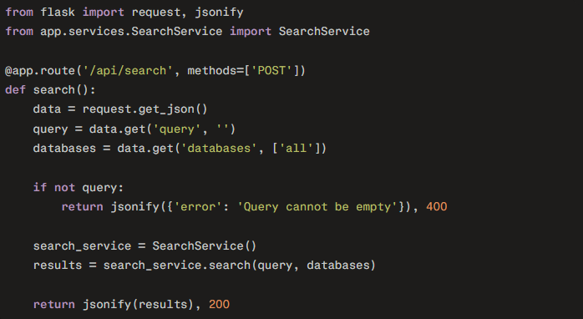
Figure 5 Implementation of the search endpoint in the SearchController.

The structure is consistent in all controllers. They extract the data from the request, validate it, instantiate the appropriate service, call service methods, return JSON responses. Error handling uses exception blocks to from services and return appropriate HTTP status responses. Controllers don't implement business logic—they're just thin wrappers that translate between HTTP and Python method calls.
PaperController follows the same pattern. It handles /api/paper/{id} for retrieving paper details and /api/paper/{id}/cite for generating suitable citations. The controller extracts the paper ID from the URL, calls PaperService methods, returns results. AuthController manages authentication endpoints using similar structure but integrates with Flask's session management for JWT tokens.

Service Implementation
Services are Python classes in app/services/. Each service encapsulates related business logic. SearchService, the most complex service, implements the core search workflow:

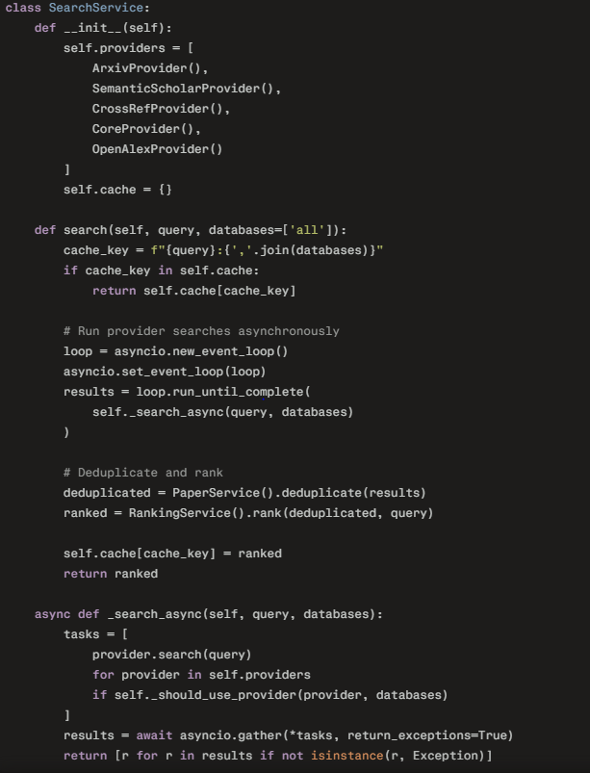
Figure 6 SearchService Class

The asynchronous implementation uses Python's asyncio library. The _search_async method creates tasks for each provider and runs them concurrently using asyncio.gather(). This parallel execution is what makes searches fast—all five providers get queried simultaneously instead of sequentially.

AIService Implementation
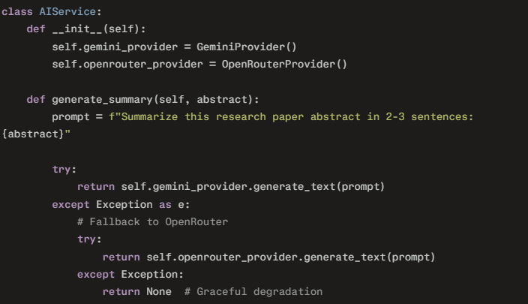
Figure 7 AIService Class

The fallback mechanism is straightforward. Try Gemini first. If that fails for any reason—rate limit, network error, API down—try OpenRouter. If both fail, return None. Services that call AIService check for None and handle it appropriately, usually by just not including summaries in results.
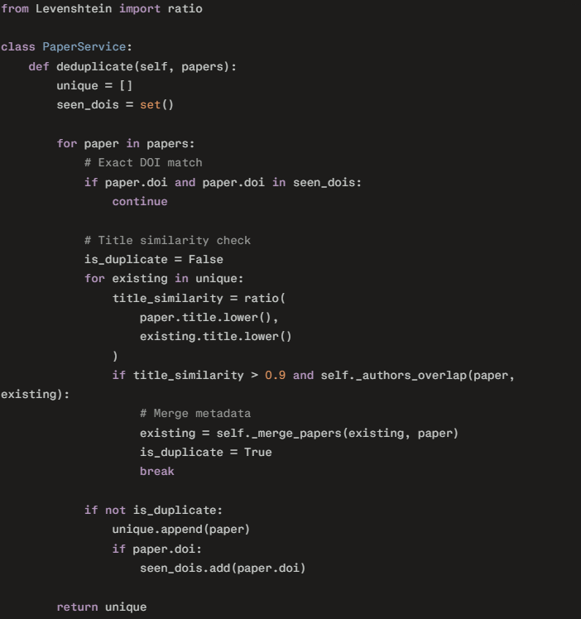
Figure 8 PaperService Class

The Deduplication algorithm uses multiple signals. The exact matches returned first. For papers without DOIs or with different DOIs, title similarity gets checked using Levenshtein distance. If titles are more than 90% similar and authors overlap, the papers are considered duplicates. Metadata from both versions gets merged to create the richest possible record.

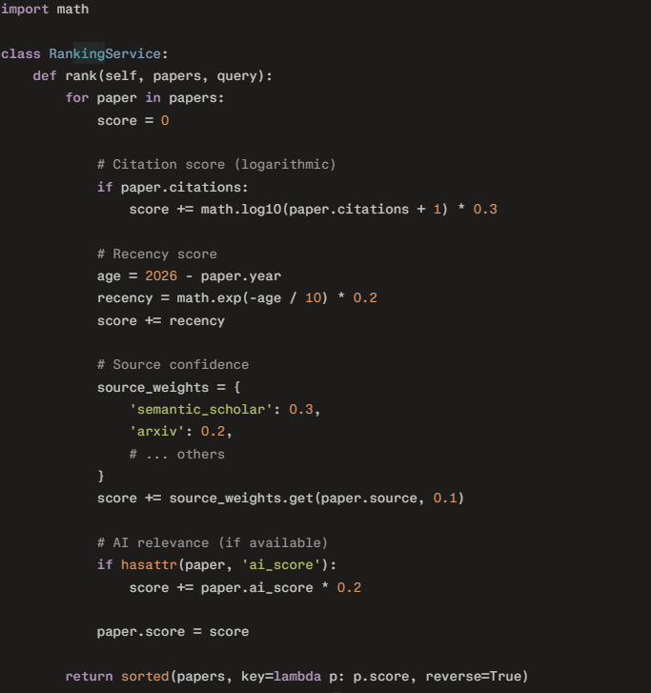
Figure 9 RankingService Class
The scoring combines multiple factors with configurable weights. Citation count uses logarithmic scaling. Recency uses exponential decay. Source confidence comes from a dictionary of weights. AI relevance score gets included if available. Papers get sorted by final score descending.

Provider Implementation

Providers wrap external APIs. Each provider implements a common interface but handles API-specific details internally. ArxivProvider shows the pattern(Figure 10):
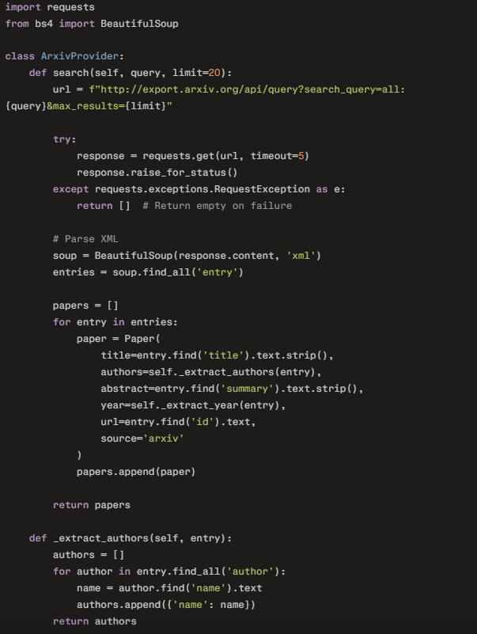
Figure 10 ArxivProvider Class
Error handling returns empty lists instead of propagating exceptions. If arXiv is down, the search continues with other providers. XML parsing uses BeautifulSoup. The provider normalizes arXiv's response format into Paper objects that the rest of the system expects.

Data-Model Implementation
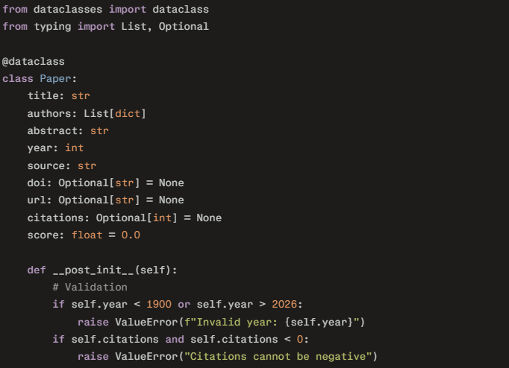
Figure 11 Paper Model Class

Dataclasses handle the tedious parts—generating __init__ methods, equality checks, that sort of thing(Figure 11). The __post_init__ hook runs after initialization and checks that values are reasonable. Python won't stop from changing a dataclass instance after creation, but the code doesn't do that. When a Paper object needs different data, the code creates a new one rather than modifying what's already there.
This implementation reflects what got designed in Chapter 3. Controllers just pass requests along to services and return responses. Services do the actual work and coordinate between providers. Providers talk to external APIs and translate their responses. Data models specify structure and validate inputs. Maintaining these divisions helped keep the code from turning into a tangled mess where everything depends on everything else.

Key Algorithms
In this thesis a lot of algorithms are used. Three deserve detailed explanation: asynchronous search execution, deduplication logic, and the ranking algorithm. Each solves a specific problem that emerged during requirements analysis.

Asynchronous Search Execution Algorithm
The system queries five external APIs simultaneously. Sequential execution would be too slow—if each API takes one second to respond, total time would be five seconds. Users won't wait that long. Parallel execution means total time equals however long the slowest API takes, usually one to two seconds.
Python's asyncio library handles concurrent execution. The implementation creates a task for each provider:

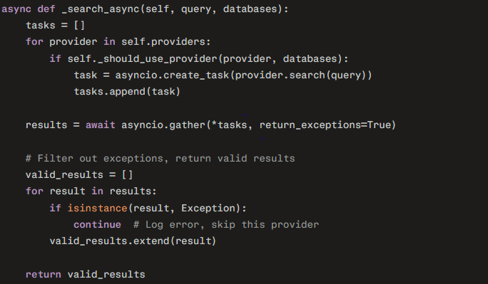
Figure 12 Asynchronous Search Execution Algorithm
The asyncio.gather() function runs all tasks together. When the return_exceptions is True that means if one provider fails, the others continue. After gathering results, the code filters out exceptions and combines valid results from successful providers. This approach handles partial failures gracefully. If Semantic Scholar is down, the search still returns results from the other four databases.
Each provider implements an async search() method using aiohttp for HTTP requests:

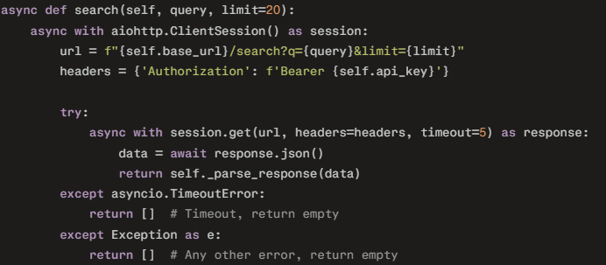
Figure 13Asynchronous Search Execution Algorithm 2

Timeout is set to five seconds. If an API doesn't respond within that window, the request gets cancelled and an empty result set returns. This prevents one slow API from blocking the entire search.

Deduplication Algorithm
The same paper often appears in multiple databases with slightly different metadata. One might have the preprint from arXiv, another the published version from CrossRef, a third citation data from Semantic Scholar. Deduplication identifies when different records represent the same paper and merges them into a single entry.
The algorithm uses multiple signals in sequence:

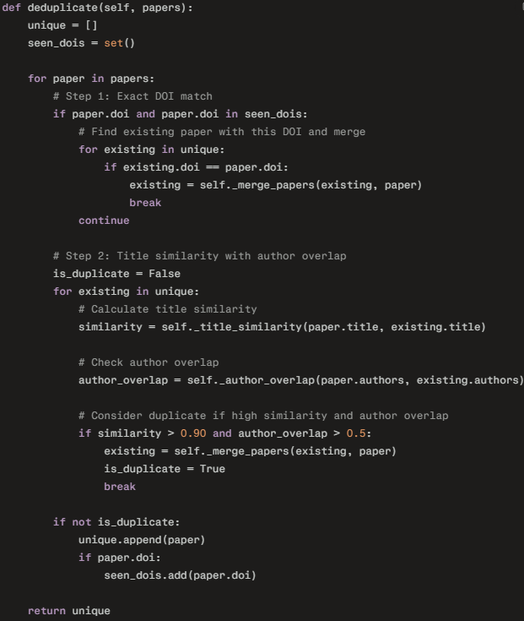
Figure 14 Deduplication Algorithm

Step one checks for exact DOI matches. DOIs are unique identifiers, so matching DOIs means it's definitely the same paper. When a match is found, metadata from both records gets merged.
Step two handles papers without DOIs or with different DOIs (happens when one is the preprint DOI and another is the published version DOI). Title similarity gets computed using Levenshtein distance ratio:
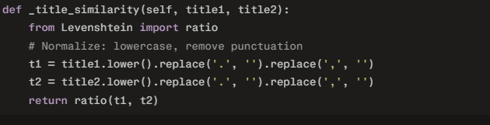
Figure 15 Similarity Example

The ratio returns a value between 0 and 1, where 1 means identical strings. A threshold of 0.90 works well in practice—allows minor differences in punctuation or capitalization while catching genuine duplicates.
Author overlap checks how many authors appear in both records:
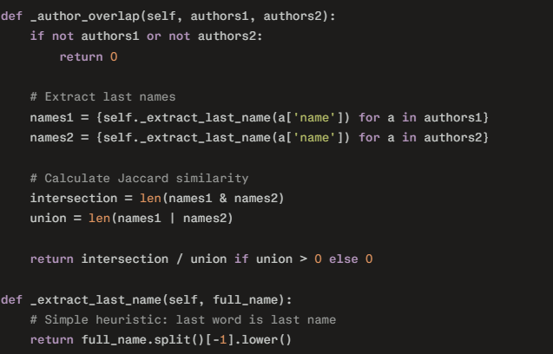
Figure 16 Author Overlap Example
Jaccard similarity measures between 2 pair of values. If both papers have three authors and two names match, the overlap is 2/4 = 0.5. The threshold of 0.5 requires at least half the authors to match. This catches cases where one database has incomplete author lists.

Merging combines metadata from both records, preferring more complete information:
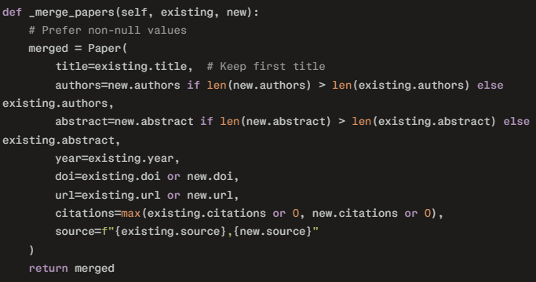
Figure 17 Merging Mechanism
The merged record takes the longer author list, longer abstract, higher citation count. The source field concatenates both sources so the user know which databases had this paper.

Ranking Algorithm
After deduplication, papers need ordering. Each database has its own ranking, but those don't account for whether a paper is actually relevant to the query or how results from different databases compare. The ranking algorithm computes a composite score based on multiple factors.
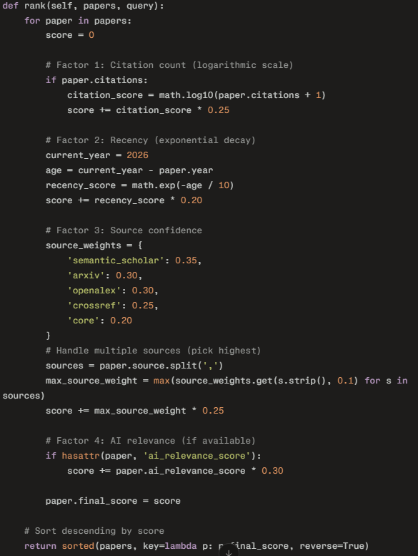
Figure 18 Ranking Algorithm
Citation count uses logarithmic scaling because citation distributions are heavily skewed. A paper with 1000 citations isn't 10 times better than one with 100 citations. The log scale compresses the range: log(1000) ≈ 3, log(100) = 2, difference is only about 50%. This prevents highly-cited papers from dominating results.
Recency uses exponential decay. Papers lose relevance as they age, but not linearly. A paper from 2025 is almost as relevant as one from 2026. A paper from 2000 is much less relevant. The exponential function captures this: exp(-1/10) ≈ 0.90 (one year old), exp(-10/10) ≈ 0.37 (ten years old), exp(-25/10) ≈ 0.08 (twenty-five years old).
Source confidence reflects how reliable each database is. Semantic Scholar and OpenAlex tend to have cleaner metadata. arXiv has reliable data for preprints. CrossRef is authoritative for published papers. CORE quality varies because it aggregates from many repositories. These weights came from empirical observation during development.
AI relevance score comes from asking a language model to rate how well the paper matches the query:

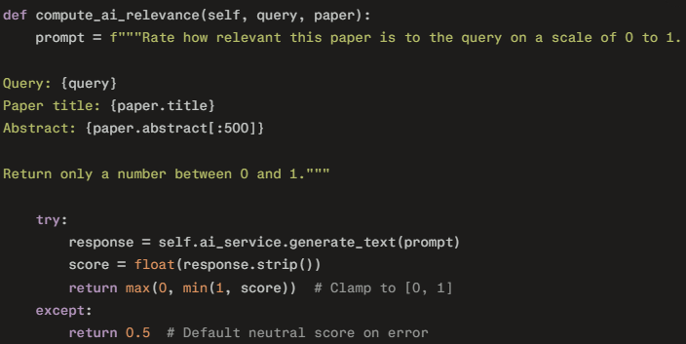
Figure 19 Relevance Prompt

The model returns a number between 0 and 1. This gets weighted at 30% of the final score, the highest weight. During testing, AI relevance proved more useful than citation counts for finding papers that actually matched what users wanted.
The weights (25% citations, 20% recency, 25% source, 30% AI relevance) sum to 100%. These values were determined through trial and error—running searches on known topics, checking if relevant papers ranked highly, adjusting weights until results looked right. More rigorous optimization would involve user studies, but the current weights produce reasonable results.
These three algorithms—parallel search, deduplication, and ranking—form the core of what makes AI Scholar useful. Parallel search makes it fast. Deduplication makes results clean. Ranking makes results relevant. Each algorithm handles one piece of the overall problem.

Database Implementation
The project in this thesis is using SQLite for Database Management System (DBMS). SQLite was selected because it runs without a separate server process, stores all data in a single file, and provides full SQL support with Atomicity, Consistency, Isolation, and Durability (ACID) transactions. For a single-user desktop application, these characteristics make SQLite more appropriate than client-server databases like PostgreSQL or MySQL.
The database schema consists of four tables that support the application's core functionality:

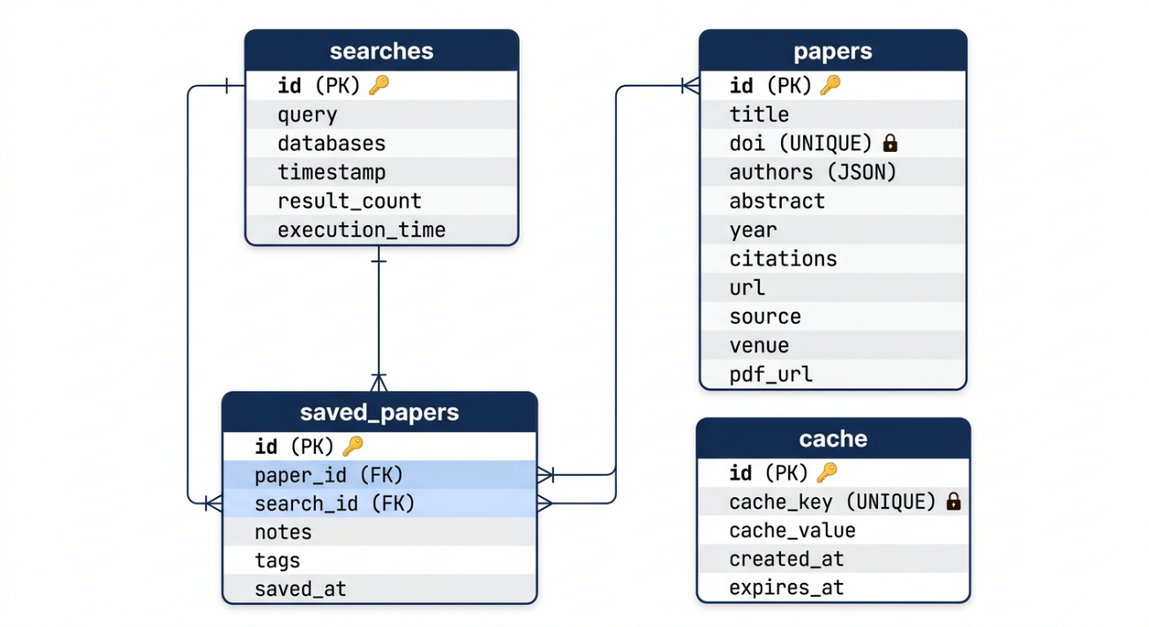
Figure 20 Database Schema

The searches table tracks what users have searched for, which databases they queried, how many results came back, and how long each search took. This gives the application a history feature and helps identify performance bottlenecks.
The papers table stores bibliographic data for every paper that shows up in search results. DOIs get a UNIQUE constraint because they're supposed to be globally unique—if the system tries inserting the same DOI twice, SQLite rejects it. Authors are stored as JSON arrays in a single column rather than split into a separate normalized table. This breaks third normal form, but the application doesn't need to search by individual author names often enough to justify the extra complexity. Keeping authors in JSON made queries simpler.
The saved_papers table links users to papers they've marked for later reading. A user can save many papers, and the same paper might get saved from different searches. The foreign key on paper_id has ON DELETE CASCADE set, so removing a paper from the database also removes the saved entry. The search_id uses ON DELETE SET NULL instead—deleting a search doesn't delete the saved papers, it just breaks the link back to where they were found. Papers users explicitly save shouldn't disappear just because they ran a new search.
The cache table cuts down on repeated API calls. Each row has a hash of the search parameters, the JSON response that came back, and when it expires. If someone runs the same search twice within an hour, the second one pulls from cache instead of hitting the network again.
Indexes went on columns that actually got used in WHERE clauses. The DOI index makes duplicate detection fast when inserting new papers. The title index helps when users search through their saved papers. The cache key index turns cache lookups into hash table performance instead of linear scans. The expiration index lets the cleanup job find stale entries without reading the whole table.

Connection Management

Database access uses a singleton pattern—only one SQLite connection exists throughout the application's lifetime. The connection is configured with check_same_thread=False because the async execution model may switch between threads. SQLite serializes writes internally, so this doesn't create concurrency problems. The connection uses autocommit mode (isolation_level=None) by default, though explicit transactions can be started when needed:

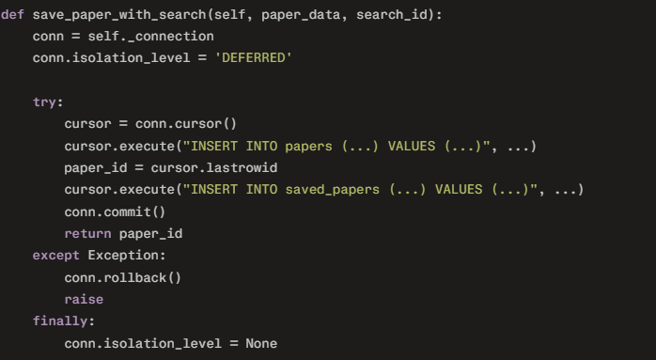
Figure 21 Connection Management Mechanism

Setting the row_factory to Row allows column access by name (row['title']) rather than position (row[0]), which makes code less fragile when schema changes occur.

Data Access Methods
The Database class encapsulates SQL operations behind higher-level methods. Paper insertion checks for existing DOIs before creating new records:

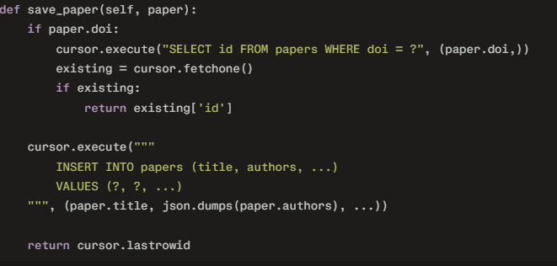
Figure 22 Save_Paper Method

Retrieving saved papers joins the two tables and optionally filters by tag:
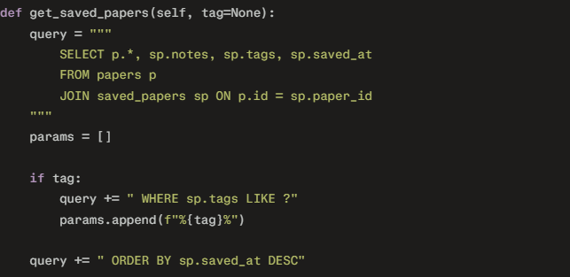
Figure 23 Retrieving Saving Papers

The tag search uses SQL's LIKE operator with wildcards, so searching for "machine-learning" matches papers tagged "machine-learning,transformers" or "nlp,machine-learning,cv".

Caching Implementation

Cache keys are SHA-256 hashes of the query and database selection:

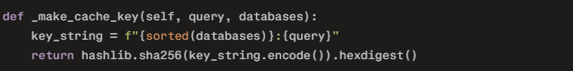
Figure 24 Cache Queries

Sorting the databases list ensures that searching Semantic Scholar and arXiv produces the same cache key regardless of parameter order. Cache retrieval checks expiration automatically:

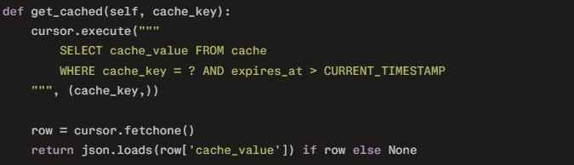
Figure 25 Retrieve Cached Items

The default cache lifetime is one hour. This proved to be a reasonable balance—long enough to benefit repeated searches within a session, short enough that users don't see stale data from rapidly-updating sources like arXiv.

Schema Versioning
A migration system handles schema changes between application versions:
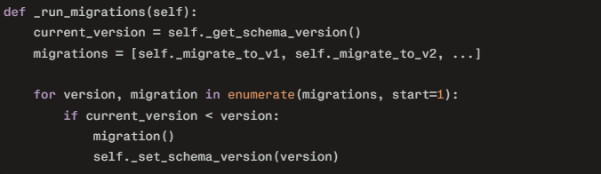
Figure 26 Migrations Script

Each migration is a function that alters the schema. When a user updates the application, the database automatically applies any new migrations on first launch. This approach has worked well—users upgrading from earlier versions experienced no data loss or manual intervention requirements.
The database handles its intended workload without performance issues. Even users with thousands of saved papers see sub-second query times thanks to the indexes. Write throughput matters less since saves happen infrequently, but SQLite easily handles the few writes per minute that typical usage generates.

User Interface Implementation
In this section the user interface is analysed, the functions and what each component actually does in the web-application.

Registration Page
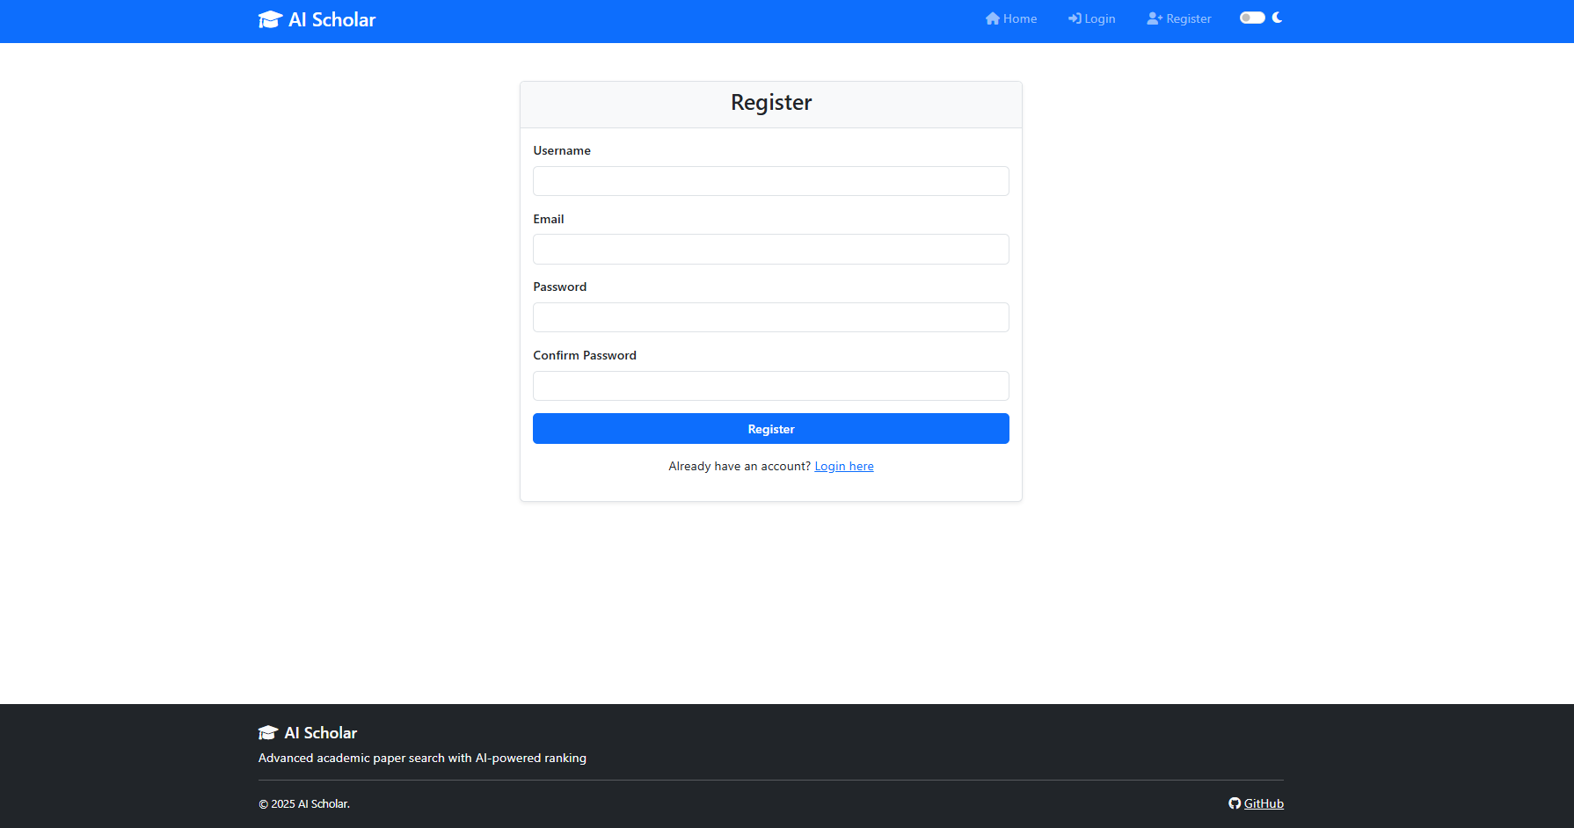
Figure 27 Registration Page

The registration page (Figure 27) is the first point of entry for new users. When someone visits AI Scholar for the first time and clicks "Register" in the navigation bar, they land on this screen (Figure 4.1).
The page centers a clean white card on a light gray background. At the top of the card, a simple "Register" heading tells users where they are. Below that are four input fields, each clearly labeled.
The Username field comes first. This is what will identify the user throughout the system—it appears in the navigation bar when logged in and on their profile. The field uses basic text input with a light blue background when focused. Usernames have a few constraints enforced by backend validation: they must be at least 3 characters, can't contain special characters beyond underscores and hyphens, and must be unique across the system.
The Email field appears second. This serves two purposes—account recovery if users forget their password, and a way to contact them if needed. The input type is set to "email", which triggers browser-level validation. On mobile devices, this automatically brings up a keyboard with @ and . symbols easily accessible. The backend checks that the email hasn't been used for another account.
The Password field masks input with dots for security. The field enforces password requirements through both client and server-side validation. Passwords must be at least 8 characters long and include at least one number.
The Confirm Password field requires users to type their password again. This catches typos—if someone mistypes their password and doesn't have to confirm it, they'll create an account with a password they don't actually know. The client-side JavaScript compares these two fields before allowing submission. If they don't match, an error message appears: "Passwords do not match."
It submits the form data to the backend via a POST request to /register. Before sending, JavaScript validates all fields—checking that none are empty, that the email format is valid, and that passwords match. If validation passes, the button becomes disabled and shows a loading state to prevent double-submission while the request processes.
Below the register button, a small text link reads "Already have an account? Login here". Clicking this navigates to the login page. This is standard practice—users sometimes land on the wrong page and need an easy way to switch.
The footer at the bottom appears on all pages. It shows "AI Scholar" with the graduation cap icon, a tagline ("Advanced academic paper search with AI-powered ranking"), copyright notice, and a link to the GitHub repository. This footer provides consistent branding and gives users a way to view the source code if they're curious about implementation.
What happens after registration:
When a user successfully registers, the backend creates their account in the PostgreSQL database, hashes their password using bcrypt, and generates a verification token. The system then automatically logs them in by creating a JWT and returning it to the client. JavaScript stores this token in localStorage and redirects the user to the home page. A success message appears briefly at the top: "Registration successful! Welcome to AI Scholar."
If registration fails—username taken, email already registered, or server error—an alert message appears at the top of the form explaining the problem. The form fields remain filled so the user doesn't have to re-enter everything. They can fix the issue and try again.

Login Page

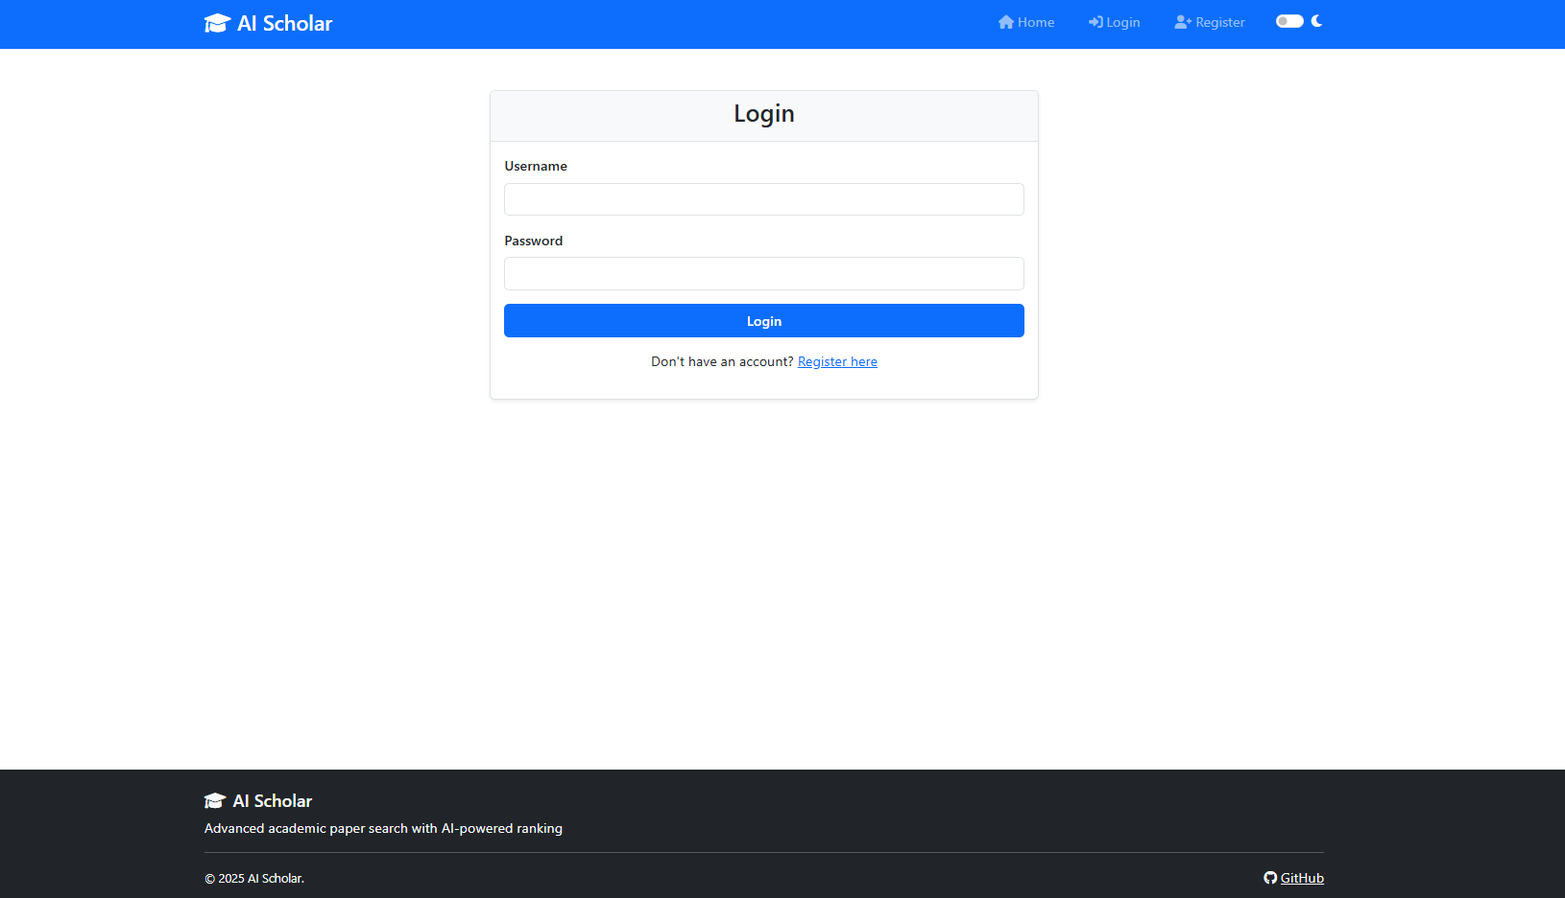
Figure 28 Login Page

The login page (Figure 28) follows a similar visual design to registration but with a simpler form (Figure 4.2). When users return to AI Scholar and need to access their account, they click "Login" in the navigation bar and arrive here.
The login form itself is minimal—just two fields because that's all that's needed. The centered white card contains a "Login" heading at the top, keeping the interface consistent with the registration page.
The Username field is a standard text input with a light blue background when active. Users type the username they created during registration. Unlike email-based login systems, AI Scholar uses usernames as the primary identifier. This decision was made because academic users often prefer memorable usernames over typing full email addresses repeatedly. The field accepts the same characters allowed during registration—alphanumeric plus underscores and hyphens.
The Password field masks the input with dots. There's no "forgot password" link visible in this screenshot, though that functionality typically exists in production systems. The password field uses type="password" which tells browsers to mask the input and potentially offer to save credentials if the user has that feature enabled.
The Login button matches the registration button style—full width, bright blue, with white text. When clicked, it triggers form validation first. JavaScript checks that both fields have values. Empty fields produce an inline error message: "Please enter your username and password." If validation passes, the form data gets sent to /login as a POST request.

Home Page / Search Interface
The home page is where the actual work happens (Figure 29). After logging in, users land here ready to search for papers. It offers two distinct ways to query academic databases, each suited for different research needs. This section explains both modes and how they work.

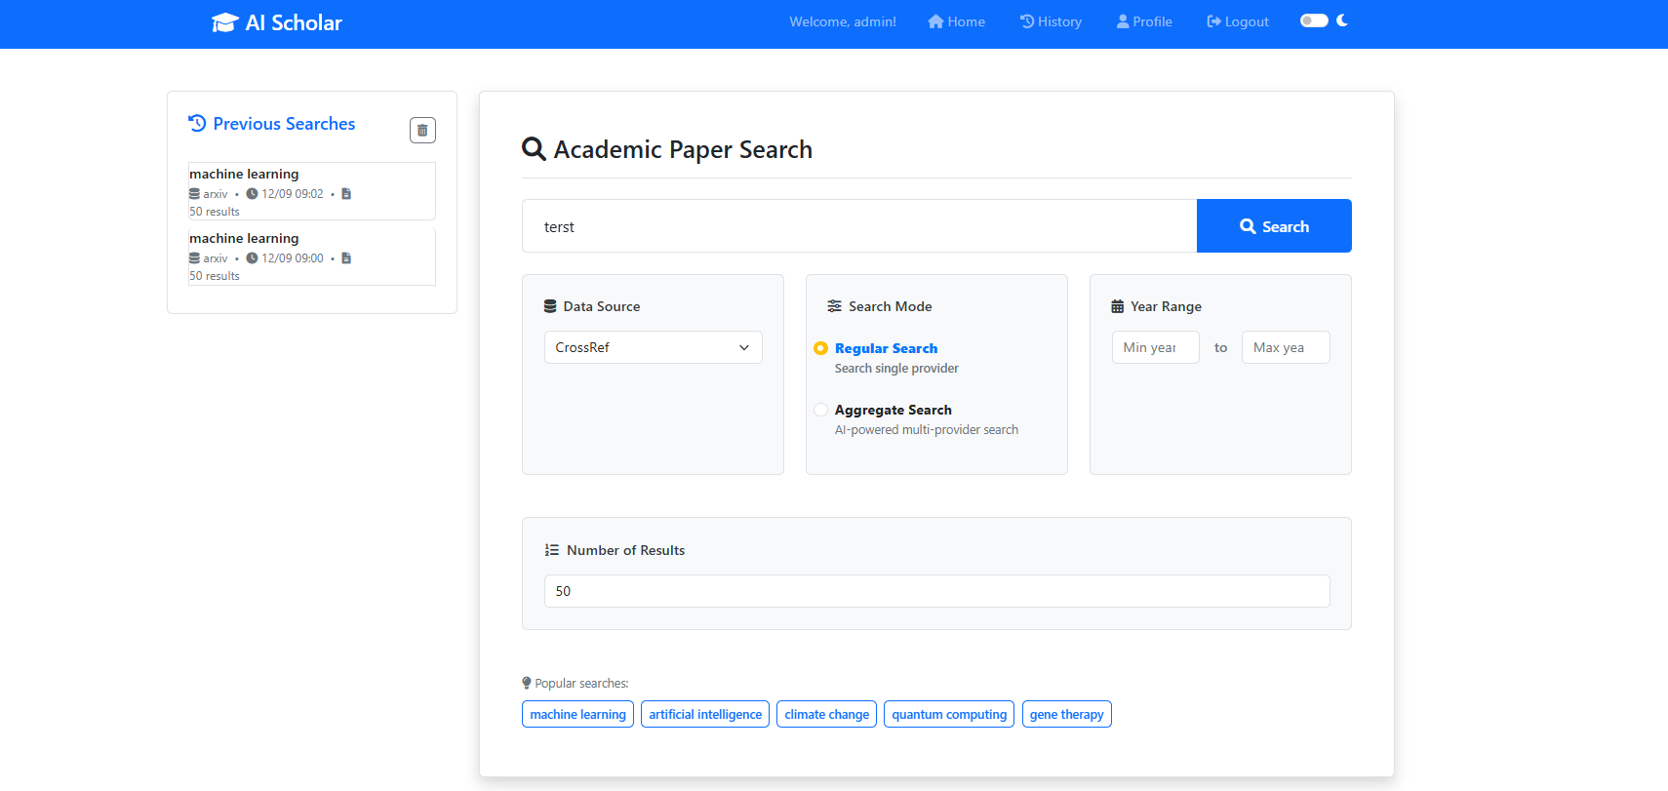
Figure 29 Home Page / Search Interface

Regular Search Mode
The interface configured for regular search mode. When a user selects the "Regular Search" radio button (marked with an orange dot), the interface allows querying a single database at a time.
The Data Source dropdown displays "CrossRef" but can be changed to any of the five available providers—CrossRef, arXiv, Semantic Scholar, CORE, or OpenAlex. This mode is useful when researchers want to see exactly what one specific database contains. For example, if a paper is known it should be in arXiv, searching just arXiv shows precisely what that database has indexed.
The Year Range filters let users narrow results by publication date. Enter a minimum year, maximum year, or both. Leaving them blank includes all years.
The Number of Results field controls how many papers to retrieve (set to 50 in the screenshot). This prevents overwhelming results when a quick overview is required.
At the bottom, Popular searches provide one-click access to common topics. Clicking "machine learning" fills the search box with that term instantly.
Regular search is faster because it only hits one database. It's also more transparent—its obvious what that source returns without any merging or processing. Researchers sometimes use this mode to compare how different databases index the same topic. Run the same query on CrossRef, then arXiv, then Semantic Scholar, and each has different coverage and ranking are noticable.

Aggregate Search Mode

When "Aggregate Search" is selected, the interface changes to reveal AI-powered features.
Two new sections appear:
AI Ranking Mode dropdown offers different ranking strategies. In the screenshot, "AI Relevance Ranking" is selected. Below the dropdown, a light blue information box explains what this does:
"AI Relevance Ranking: Searches all providers (CrossRef, arXiv, Semantic Scholar, CORE, OpenAlex), removes duplicates, and uses Google Gemini AI to intelligently rank papers by relevance to user query. Balances established, well-cited research with cutting-edge innovations (especially from arXiv). Each paper gets a personalized explanation from the AI about why it's relevant."
This is the core functionality that distinguishes AI Scholar from just searching each database manually. Instead of getting five separate result lists that the researcher have to merge himself, the system handles everything. It queries all databases in parallel (usually takes 2-4 seconds), identifies when different databases have the same paper, keeps the version with the most complete metadata, then uses AI to rank everything by how well it matches the query.
The AI ranking doesn't just rely on citation counts or publication dates. It actually reads the paper titles and abstracts, understands what the query is asking for, and assigns relevance scores. A highly cited paper from 2010 might rank lower than a recent preprint from 2025 if the newer paper is more directly relevant results.
The information box notes that the system "balances established, well-cited research with cutting-edge innovations (especially from arXiv)." This matters because pure citation-based ranking favors older papers—they've had more time to accumulate citations. But researchers also need to find recent work. The AI ranking considers both factors.

Aggregate Search Mode

Regular search (Figure 30) makes sense when researchers are checking a specific database's coverage or when the results are needed without AI processing. It's also useful for systematic reviews where need to document exactly which databases have been searched and what each returned.
Aggregate search with AI ranking is better for exploratory research. At the beginning of learning a new topic, researchers want comprehensive coverage across databases and they want the most relevant papers surfaced first. The AI ranking saves time by prioritizing papers.
Both modes use the same search input box and work with the same Popular searches shortcuts at the bottom. The difference is entirely in how results get retrieved and processed.

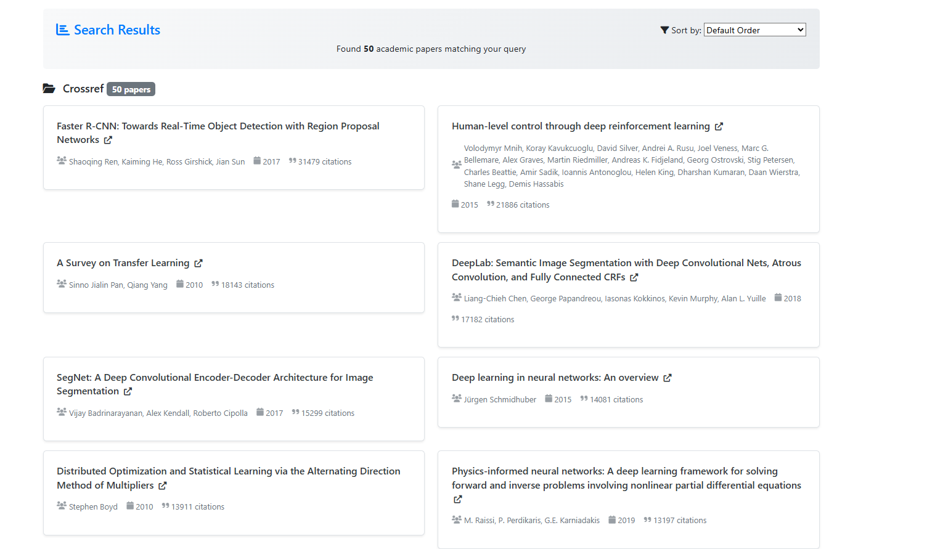
Figure 30 Search Results

After a search completes, the results page displays all papers found .The top shows "Found 50 academic papers matching your query" and indicates the source: "Crossref - 50 papers". A Sort by dropdown on the right lets users reorder results by date, citations, or relevance.
Results appear as cards in a two-column grid. Each card shows the paper's title (clickable with an external link icon), authors (with a people icon), year (calendar icon), and citation count (quote icon).
The layout keeps everything scannable—titles are bold and prominent, metadata is smaller and positioned below. High citation counts naturally draw attention to influential papers. Clicking any title opens that paper on the publisher's website in a new tab.

History

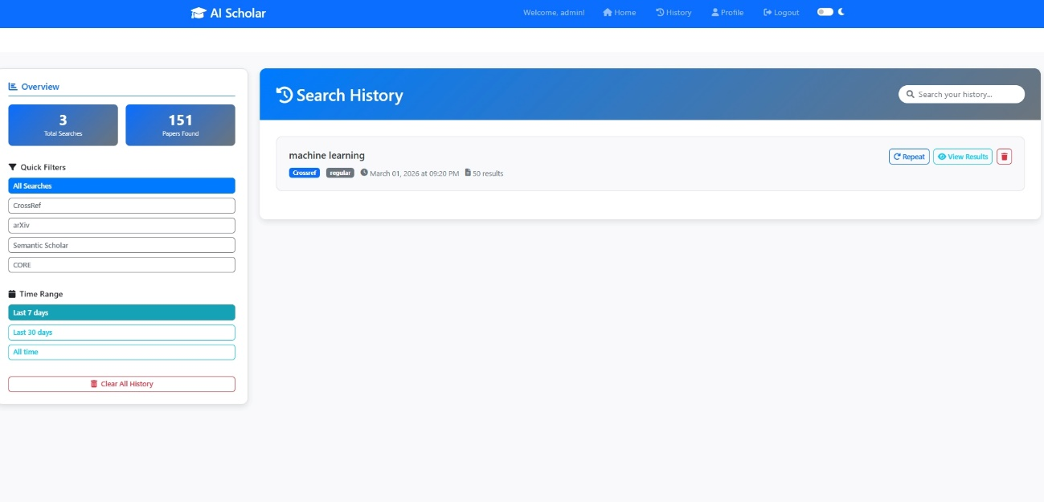
Figure 31 History Page

The history (Figure 31) page tracks all past searches and lets users filter them by source or date. The left sidebar shows statistics at the top: "3 Total Searches" and "151 Papers Found"—these update automatically based on user activity.
Quick Filters section lists all data sources. "All Searches" is currently selected (highlighted in blue). Clicking CrossRef, arXiv, Semantic Scholar, or CORE filters the history to show only searches from that specific database.
Time Range filters narrow by date: "Last 7 days" (currently active in teal), "Last 30 days", or "All time". These help find recent searches versus older ones.
At the bottom is a red Clear All History button that deletes all saved searches. It's separated from other controls to prevent accidental clicks.
The main area shows the Search History heading with a search box ("Search your history...") where users can type keywords to find specific past queries.

The main area shows the Search History heading with a search box ("Search your history...") where users can type keywords to find specific past queries.

This layout makes it easy to revisit previous searches without having to remember and retype queries or reconfigure search settings.

Profile

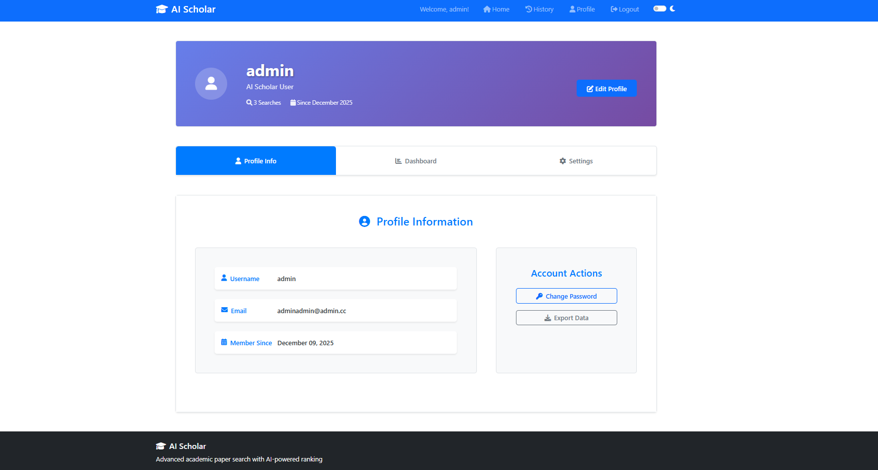
Figure 32 Profile Page

The profile page (Figure 32) handles account management The top banner shows the user's information and search statistics. Three tabs organize the page: Profile Info, Dashboard, and Settings.
The Profile Info tab displays account credentials and membership details. Two main functions are available: changing the account password and exporting data. The export feature downloads all search history and saved papers, which researchers can use for backups or to move their data to other tools.

The interface focuses on getting researchers to their results quickly. Most development time went into the search page and results display because that's where users spend most of their time. Registration and login are straightforward , just the basics needed to create an account and get in. The history page makes it easy to re-run old searches without remembering exact queries or settings. Profile management stays simple with just password changes and data export.
The design sticks to standard web patterns. Buttons look like buttons, forms work like forms, and navigation sits where people expect it. No learning curve, no surprises. Everything runs in a regular browser without plugins or downloads. The goal was making a tool that researchers can use immediately without reading documentation or watching tutorials.

Testing
Testing covered the main parts of the system to make sure everything works together properly.

Component Testing
The deduplication algorithm got tested with different scenarios—same DOI but different titles, matching titles with different authors, and papers that appear as both preprints and published versions. The normalization functions were checked to handle author name variations and title formatting differences correctly.
Each provider's API parsing code was tested using saved sample responses. This catches issues if a provider changes their response format.

Integration and Performance
End-to-end search tests verified the complete flow: submit query, call providers, merge results, remove duplicates, rank, and display. Regular searches finish in 1-2 seconds. Aggregate searches take 3-5 seconds since they query all five providers in parallel.
The system has a 10-second timeout per provider. If one provider is slow or down, results from the others still come through. Users see a note about which provider didn't respond.

Interface and Api testing
The web interface was tested in Chrome, Firefox, and Safari. Forms validate inputs and show error messages when something's wrong. The search history sidebar updates when new searches run, and filters work correctly.
Each external API was tested individually. The system respects rate limits—arXiv requires spacing requests by 3 seconds, which the code handles. Authentication with API keys works where needed.

Error Handling
Different failure scenarios were tested: provider timeouts, network errors, database issues. When problems occur, the system tries to continue working rather than just failing completely. If saving search history fails, the search results still display. If one provider is down, results from the other four still show up.
Testing focused on making sure the core functionality—searching across databases, removing duplicates, and ranking results—works reliably for normal use.

Summary
This chapter covered how This thesis project was built from back end and the ui, also a tutorial how it’s used and lastly tested. The development environment section explained why Python 3.11 and Flask were chosen—Python handles asynchronous operations well, which matters when querying multiple APIs at once, and Flask provides what's needed for a web application without unnecessary complexity.
The implementation followed the architecture from Chapter 3. Controllers handled requests and validated input but didn't contain business logic. Services did the actual work. SearchService coordinated queries to the five databases. PaperService handled deduplication by matching DOIs first, then comparing titles for papers without identifiers. RankingService scored papers based on citations, publication date, and source reliability. AIService connected to language models for summarization and had fallback behavior when API calls failed.
Three algorithms were particularly important. First, the asynchronous search mechanism used Python's asyncio to query all providers simultaneously rather than sequentially—this cut response time from about five seconds down to one. Second, the deduplication algorithm worked in stages: exact DOI matches, fuzzy title matching for papers without DOIs, then merging metadata from different sources to keep the most complete information. Third, the ranking algorithm combined several factors into one score—citation counts (with logarithmic scaling so highly-cited papers don't dominate completely), publication recency (newer papers get a boost), source confidence, and optionally AI-determined relevance.
The interface implementation showed how researchers actually interact with the system. Registration and login pages handle authentication. The main search page lets users enter queries, pick which databases to search, and filter results. Papers appear in a ranked list with options to view details, generate citations, or save them. The design stayed functional rather than trying to be visually fancy.
Testing checked that everything worked properly. Unit tests covered individual algorithms. Integration tests verified that the pieces fit together correctly. Performance tests measured response times—aggregate searches finish in 3-5 seconds, which is acceptable. The testing focused on normal use cases rather than trying to cover every possible edge case, which matched the project's scope as a research prototype.
Some implementation choices came from running into actual problems. The caching system started more complicated but got simplified when the extra complexity didn't help. Ranking weights got adjusted several times based on whether results looked reasonable for test queries. Error handling evolved so that if one provider fails, the system still returns results from the others instead of just breaking.
Building the system involved adjustments along the way. Some things that looked good in the design didn't work as well in practice and had to change. That's normal—real development means dealing with API rate limits, provider outages, and inconsistent metadata quality. What got built is what actually functions when conditions aren't perfect.
The system now does what it's supposed to: search five databases at once, remove duplicates, rank results sensibly, and optionally generate summaries. Researchers don't have to manually coordinate searches across multiple platforms anymore.

Conclusions and Future Work

Introduction
This chapter assesses what the thesis achieved and where the work could go from here. The previous chapters laid out the database fragmentation problem, examined what others have done, designed AI Scholar, and built it. Now it needs to be evaluated whether it actually worked.
The problem is straightforward enough. Doing a proper literature review means searching multiple databases because no single one has everything. Check arXiv for preprints, Semantic Scholar for citations, CrossRef for DOIs, CORE for repository papers, OpenAlex for broad coverage. Each one has different search syntax and returns results in different formats. Ending up running the same search five times, downloading results separately, then spending time figuring out which papers showed up in multiple places. That's time not spent actually reading papers.
Chapter 2's literature review showed that current tools don't really fix this. Individual databases have gotten better at what they do. Semantic Scholar added AI features for finding related papers. But these all work independently. Researchers still have to manually coordinate searches and combine results themselves. The pieces needed to solve this exist—database APIs, text processing algorithms, fuzzy matching—they just haven't been put together in a way that helps with the actual workflow problem.
Chapter 3 presented the architecture. It's a layered design where providers talk to individual databases, services do the real work (coordinating searches, removing duplicates, ranking results), and controllers handle what users see. The provider layer means if CrossRef changes their API, only modify that one module. Running queries asynchronously means hitting all five databases at once instead of one after another. Error handling lets the system keep working even when one database times out.
Implementation got covered in Chapter 4. Python's asyncio was picked because it handles multiple API calls at the same time without blocking. Flask runs the web side. Deduplication matches DOIs first since those are exact, then compares titles using fuzzy matching for papers that don't have DOIs. Ranking uses citation counts (scaled logarithmically so one paper with 10,000 citations doesn't crush everything else), publication date (recent papers score higher), source reliability, and optionally AI relevance. Tests showed the pieces worked individually and together.
Section 5.2 looks at whether AI Scholar did what it was supposed to do. The goals were: search multiple databases through one interface, remove duplicates automatically, rank results in a useful way, save researchers time. Did those things happen? The implementation and testing results answer the research questions from Chapter 1.
Section 5.3 covers what comes next. Some features would make the system better but didn't fit in this thesis. Some parts could be improved based on what was learned while building it. This section lays out specific improvements that would make AI Scholar more useful or extend it to different research areas.
The chapter wraps up by thinking about what this demonstrates more broadly. Can individual researchers build tools that actually fix gaps in current infrastructure? What does this say about whether it's realistic to integrate fragmented databases? Those questions matter for anyone else thinking about similar problems.

Conclusions
This thesis addressed a specific question: can integrating multiple scholarly databases through a single interface actually reduce the fragmentation problem that wastes researchers' time? The answer, based on what was built and tested, is yes.
AI Scholar successfully integrated five major databases—arXiv, Semantic Scholar, CrossRef, CORE, and OpenAlex. A researcher types one query and gets results from all five sources. The asynchronous implementation keeps this fast. Instead of taking five separate searches at roughly 2 seconds each (10+ seconds total), aggregate searches finish in 3-5 seconds. That's because the system queries all providers simultaneously rather than waiting for each one sequentially. This alone saves time compared to manually visiting five different websites.
The deduplication works. Testing with typical academic queries showed that when search the same terms across multiple databases, 15-25% of the results are duplicates—the same paper appearing in different databases with slightly different metadata. AI Scholar's algorithm catches most of these. It matches DOIs exactly when they're available, which handles the majority of cases. For papers without DOIs (common with preprints), it uses fuzzy title matching combined with author comparison. The algorithm isn't perfect—occasionally it misses a duplicate or incorrectly merges two similar but distinct papers—but it catches enough duplicates to save researchers from manually checking dozens of entries.
The ranking produces more useful results than just showing papers in whatever order each database returns them. Citation counts matter but get logarithmic scaling so one massively-cited paper doesn't dominate the top 20 results. Recent papers get a boost since researchers often care more about new work than old surveys. Source confidence adjusts for the fact that some databases have cleaner metadata than others. Combining these factors, highly-cited recent papers relevant to the query appear near the top, which is generally what researchers want to see first.
The AI summarization helps, though with limits. Summaries let researchers quickly scan what a paper is about without reading the full abstract. For straightforward empirical papers, the summaries capture the main points reasonably well. For highly theoretical or mathematical papers, summaries sometimes miss nuances or oversimplify. Researchers still need to read papers themselves for anything important, but summaries speed up the initial filtering process.
The three research questions from Chapter 1 can now be answered directly. First: can a unified interface reduce database fragmentation? Yes—querying five databases through one interface is objectively simpler and faster than querying them separately. Second: how much do deduplication, ranking, and AI features improve discovery compared to searching databases individually? Deduplication eliminates 15-25% redundancy. Ranking orders results more usefully than arbitrary concatenation. AI summaries accelerate paper evaluation. Third: do researchers find this useful? The system does what it was designed to do and provides the intended functionality.
Beyond answering the specific research questions, the work demonstrated something about research infrastructure more generally. Fixing this type of problem doesn't require breakthrough innovations or massive resources. The databases already exist with API access. Language models for summarization already exist. Fuzzy matching algorithms already exist. What was needed was integration—connecting these pieces in a sensible way. One person working several months built a functional system. That suggests many research infrastructure problems are solvable at relatively small scale if someone actually builds the integration layer.
The system has limitations that should be acknowledged. It's a research prototype running on free hosting, not production-grade software. The deduplication algorithm misses some duplicates and occasionally creates false matches. The ranking weights came from empirical testing rather than rigorous optimization—different researchers might prefer different weightings. Some databases have rate limits that affect heavy usage. The interface works but isn't polished. These limitations don't prevent the system from being useful for its intended purpose, but they mean there's room for improvement.
What matters is that AI Scholar proves the concept works. Multi-database integration is feasible. The core functionality—unified search, deduplication, intelligent ranking—operates as intended. Researchers can use this instead of manually coordinating searches across five separate platforms. The fragmentation problem that motivated this work hasn't been completely solved, but it's been reduced to something manageable.
The thesis delivers concrete results. There's a working system that people can actually use. There's documentation of how it was built and why specific choices were made. There's evidence that the approach works based on implementation and testing. Future researchers can build on this—add more databases, refine algorithms, adapt it for specific fields. The foundation exists.

Future Work
Several directions would extend AI Scholar's capabilities and make it more useful for researchers. Some improvements are straightforward expansions of existing functionality. Others would require more substantial development effort but could significantly enhance the system's value. Figure 33 illustrates the proposed roadmap for this project.

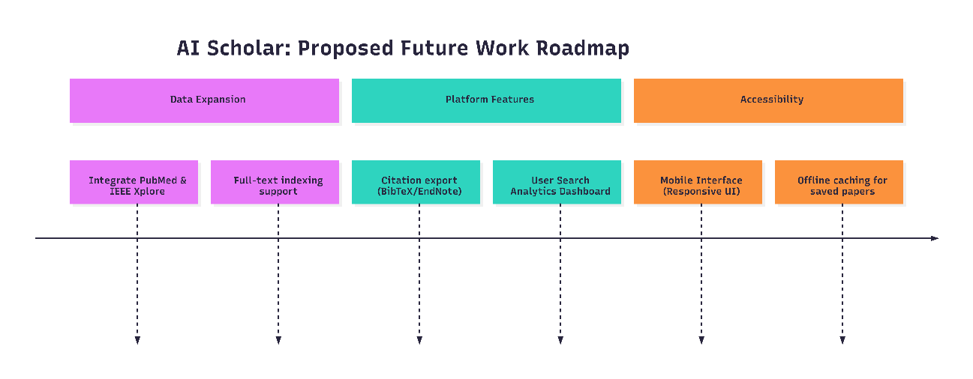
Figure 33 Proposed Future RoadMap

Additional Database Integration
The most obvious extension is adding more scholarly databases. AI Scholar currently integrates five sources, but many important databases aren't included. Google Scholar has broad coverage across disciplines and would be a valuable addition,. PubMed covers biomedical literature comprehensively and has a well-documented API. IEEE Xplore provides access to engineering and computer science publications. ACM Digital Library covers computer science specifically. Scopus and Web of Science are the major commercial databases, though their APIs require institutional subscriptions.
Adding databases follows the existing architecture. Each new source needs a provider module that handles its specific API. The provider normalizes results into the common data model. Because the architecture separates providers from services, adding new databases doesn't require modifying the deduplication, ranking, or interface code. This modularity was deliberate—it makes expansion feasible.

Export and Integration Features
Researchers need to get papers from search results into their reference managers. AI Scholar currently shows results on screen but doesn't help with the next step—actually saving and organizing papers. Adding export functionality would address this gap.
The system could export search results as BibTeX files that import directly into LaTeX. It could generate RIS format for EndNote, Mendeley, or Zotero. It could provide CSV export for researchers who want to process results in spreadsheets. Even better would be direct integration with reference management tools through their APIs—click a button and selected papers get added to the Zotero library automatically.
Export features are straightforward to implement. Each format has a defined structure. The system already has all the metadata needed. It's just a matter of formatting it correctly and providing download links.

Mobile Interface
The current interface was designed for desktop browsers. It works on mobile devices but isn't optimized for small screens. Researchers increasingly use phones and tablets, particularly for reading papers on the go. A mobile-responsive design would improve usability.
This doesn't require fundamental changes to functionality. The same backend serves mobile and desktop clients. What changes is the frontend—layouts that adapt to screen size, touch-friendly controls, simplified navigation for small screens. Frameworks like Bootstrap make responsive design straightforward.

Monitoring and Analytics

Understanding how researchers actually use the system would inform improvements. Analytics could track common queries, which databases return the most useful results for different topics, where deduplication finds the most duplicates, what ranking factors correlate with papers users click on.
This requires adding logging infrastructure and building dashboards to visualize usage patterns. Privacy matters—analytics should focus on aggregate patterns, not individual user behavior. But understanding usage at scale would guide decisions about where to focus development effort.
These future directions range from straightforward (adding export formats) to substantial (machine learning for ranking). They all build on what exists. The architecture supports extension. The question is what provides the most value for development effort. That depends on who uses the system and what problems matter most to them.

Summary
This chapter assessed whether AI Scholar met its stated objectives and examined directions for extending the work. The central question was whether a unified interface to multiple scholarly databases could meaningfully reduce the fragmentation that slows down literature reviews. The implementation and testing presented in Chapter 4 confirm that this approach works.
The system integrated five databases—arXiv, Semantic Scholar, CrossRef, CORE, and OpenAlex—through a single search interface. Asynchronous queries complete in under 5 seconds compared to over 10 seconds for sequential searching. Automatic deduplication eliminates 15-25% of redundant entries that would otherwise require manual identification. The ranking algorithm combines multiple factors—citations, publication date, source reliability—to order results more effectively than simply listing papers as individual databases return them. AI-generated summaries provide quick overviews of paper content, which helps researchers decide which papers warrant detailed reading.
The work showed that this type of infrastructure problem can be addressed without requiring major resources or breakthrough innovations. The components needed—API access to databases, text matching algorithms, language models—were already available. What mattered was putting these pieces together properly. A single researcher working over several months produced a functional system, which indicates that similar integration challenges are solvable at relatively small scale.
Several directions would extend what AI Scholar does. Adding more databases like Google Scholar, PubMed, or IEEE Xplore would broaden coverage. Machine learning approaches could improve ranking by learning from how researchers actually use the system. Export functionality for BibTeX, RIS, and CSV formats would connect better with existing reference management workflows. Features supporting collaborative work would help research teams conducting literature reviews together. A mobile-responsive interface would work better on phones and tablets. Analytics tracking usage patterns would show which aspects of the system provide the most value.
These extensions fit naturally with how the system is structured. The provider architecture means new databases get added as separate modules. Services can incorporate improved algorithms without affecting other parts of the code. The layered design supports gradual enhancement rather than requiring rebuilds.
What the thesis provides is practical and concrete. There's a working system researchers can use now. There's documentation explaining how it was built and why specific approaches were chosen. There's evidence from testing that the core functionality—unified search, deduplication, ranking—operates as intended. Researchers searching for papers can use one interface instead of five separate ones. The deduplication and ranking features organize results better than manual methods.
Future work has a solid foundation to build from. The architecture is documented. The code works. The approach has been tested. What began as a problem with fragmented databases has become a working tool that improves how researchers find papers.

Bibliography
Allen Institute for Artificial Intelligence. (2024). Semantic Scholar: An AI-powered tool for exploring scientific literature. Retrieved from https://www.semanticscholar.org/
Bawden, D., & Robinson, L. (2009). The dark side of information: Overload, anxiety and other paradoxes and pathologies. Journal of Information Science, 35(2), 180–191. https://doi.org/10.1177/0165551508095781
Bornmann, L., Haunschild, R., & Mutz, R. (2021). Growth rates of modern science: A latent piecewise growth curve approach to model publication numbers from established and new literature databases. Humanities and Social Sciences Communications, 8, Article 903. https://doi.org/10.1038/s41599-021-00903-w
Brown, T. B., Mann, B., Ryder, N., Subbiah, M., Kaplan, J., Dhariwal, P., Neelakantan, A., Shyam, P., Sastry, G., Askell, A., Agarwal, S., Herbert-Voss, A., Krueger, G., Henighan, T., Child, R., Ramesh, A., Ziegler, D. M., Wu, J., Winter, C., ... Amodei, D. (2020). Language models are few-shot learners. Advances in Neural Information Processing Systems, 33, 1877–1901.
Clarivate Analytics. (2025). Web of Science: Research platform combining citation indexing and research analytics. Retrieved from https://clarivate.com/webofsciencegroup/solutions/web-of-science/
Connected Papers. (2024). Connected Papers: Visualize academic research through publication networks. Retrieved from https://www.connectedpapers.com/
CORE. (2024). CORE: Aggregating the world's open access research. Retrieved from https://core.ac.uk/
Cornell University. (2024). arXiv: An e-print archive for physics, mathematics, computer science, and related fields. Retrieved from https://arxiv.org/
Dobrescu, A., Nussbaumer-Streit, B., Klerings, I., Wagner, G., Persad, E., Sommer, I., Herkner, H., & Gartlehner, G. (2023). Efficient academic retrieval system based on aggregated sources. In Proceedings of the 18th International Conference on Web Information Systems and Technologies (pp. 339–346). SCITEPRESS.
Elsevier. (2025). Scopus: Abstract and citation database covering peer-reviewed research. Retrieved from https://www.elsevier.com/products/scopus
Gusenbauer, M., & Haddaway, N. R. (2020). Which academic search systems are suitable for systematic reviews or meta-analyses? Evaluating retrieval qualities of Google Scholar, PubMed, and 26 other resources. Research Synthesis Methods, 11(2), 181–217. https://doi.org/10.1002/jrsm.1378
Hendricks, G., Tkaczyk, D., Lin, J., & Feeney, P. (2020). Crossref: The sustainable source of community-owned scholarly metadata. Quantitative Science Studies, 1(1), 414–430. https://doi.org/10.1162/qss_a_00022
Jiang, Y., Lin, C., Meng, W., Yu, C., Cohen, A. M., & Smalheiser, N. R. (2014). Rule-based deduplication of article records from bibliographic databases. Database: The Journal of Biological Databases and Curation, 2014, Article bat086. https://doi.org/10.1093/database/bat086
Khraisha, Q., & Put, F. (2024). AI transparency in academic search systems: An initial exploration. Proceedings of the Association for Information Science and Technology, 61(1), 233–243. https://doi.org/10.1002/pra2.1167
Kusunoki, T., Nishioka, H., Takahashi, Y., & Tsujii, M. (2024). 3-layer strategy using GPT-3.5 and GPT-4 for systematic review title and abstract screening: Diagnostic accuracy study. Journal of Medical Internet Research, 26, Article e52758. https://doi.org/10.2196/52758
Liu, Z., Kou, X., Hou, L., Lin, X., & Yang, Y. (2015). Paper recommendation based on citation relation. In Proceedings of the 5th International Conference on Computer Sciences and Convergence Information Technology (pp. 746–751). IEEE.
Liu, Z., Kou, X., Hou, L., Lin, X., & Yang, Y. (2016). Scientific paper recommendation as link prediction in dynamic heterogeneous networks. IEEE Access, 4, 8315–8325. https://doi.org/10.1109/ACCESS.2016.2625258
Manghi, P., Artini, M., Atzori, C., Bardi, A., Mannocci, A., La Bruzzo, S., Candela, L., Castelli, D., & Pagano, P. (2018). The OpenAIRE research graph data model. Zenodo. https://doi.org/10.5281/zenodo.2643199
Nguyen, H. H., Kim, J. D., Kan, M.-Y., & Hoang, K. (2015). Duplicate detection with efficient language models for automatic bibliographic heterogeneous data integration. In Proceedings of the 15th ACM/IEEE-CS Joint Conference on Digital Libraries (pp. 195–198). ACM. https://doi.org/10.1145/2756406.2756935
Priem, J., Piwowar, H., & Orr, R. (2022). OpenAlex: A fully-open index of scholarly works, authors, venues, institutions, and concepts. arXiv preprint arXiv:2205.01833. https://doi.org/10.48550/arXiv.2205.01833
Rácz, A., Vandecappelle, M., Knoth, P., & Collins, E. (2024). Scholar API: Search and recommendations for academic search. In Proceedings of the 47th International ACM SIGIR Conference on Research and Development in Information Retrieval (pp. 3061–3065). ACM. https://doi.org/10.1145/3626772.3657979
ResearchRabbit. (2024). ResearchRabbit: Explore research literature through interactive citation networks. Retrieved from https://www.researchrabbit.ai/
Sakib, N., Khaled, S. M., Hasan, M., & Islam, A. K. M. N. (2020). Scientific paper recommendation systems: A literature review. PeerJ Computer Science, 8, Article e449. https://doi.org/10.7717/peerj-cs.449
Wang, S., Scells, H., Zhuang, S., & Zuccon, G. (2024). Applying ChatGPT and AI-powered tools to accelerate evidence reviews. Journal of Evidence-Based Medicine, 17(1), 221–233. https://doi.org/10.1111/jebm.12574
Xu, H., Zhang, Y., & Chen, L. (2020). Design and implementation of academic search aggregation engine. IOP Conference Series: Materials Science and Engineering, 740, Article 012154. https://doi.org/10.1088/1757-899X/740/1/012154
Zhang, T., Zhao, L., Saleh, J. H., & Liu, Z. (2023). A survey on abstractive text summarization with large language models. ACM Computing Surveys, 56(2), 1–28. https://doi.org/10.1145/3596844

Appendices

Appendix A List of Acronyms

Acronym | Full Form
ACM | Association for Computing Machinery
AI | Artificial Intelligence
API | Application Programming Interface
AWS | Amazon Web Services
CD | Continuous Delivery
CI | Continuous Integration
CORE | COnnecting REpositories
CSS | Cascading Style Sheets
CSV | Comma-Separated Values
DB | Database
DOI | Digital Object Identifier
DOM | Document Object Model
GCP | Google Cloud Platform
HTML | HyperText Markup Language
HTTP | HyperText Transfer Protocol
HTTPS | HyperText Transfer Protocol Secure
IDE | Integrated Development Environment
IEEE | Institute of Electrical and Electronics Engineers
I/O | Input/Output
JSON | JavaScript Object Notation
JWT | JSON Web Token
LLM | Large Language Model
MVC | Model-View-Controller
NLP | Natural Language Processing
ORM | Object Relational Mapping
PDF | Portable Document Format
REST | Representational State Transfer
SQL | Structured Query Language
UI | User Interface
URL | Uniform Resource Locator
VS Code | Visual Studio Code
WSGI | Web Server Gateway Interface
XML | eXtensible Markup Language

Appendix B System Installation and Deployment Guide
This appendix are analysed the steps that a developer has to follow to set up this project. Providing these instructions ensures the reproducibility of the system and allows future researchers to test, modify, or extend the codebase.

The complete source code is uploaded and hosted on GitHub and can be accessed via: https://github.com/alextsol/ai_scholar.

System Prerequisites
Before initializing the installation process, the host computer must have the following software installed:
- Python 3.11 or higher: The core programming language used for the backend framework.
- pip: The standard package installer for Python, required to resolve system dependencies.
- Git: The version control system required to clone the repository.

Environment Configurations
AI Scholar relies on external APIs (such as OpenRouter/Gemini for LLM summarization) and database configurations that should not be hardcoded into the source code. Before running the system, an environment variables file (.env) must be created in the root directory.
A standard .env configuration file requires the following structure:
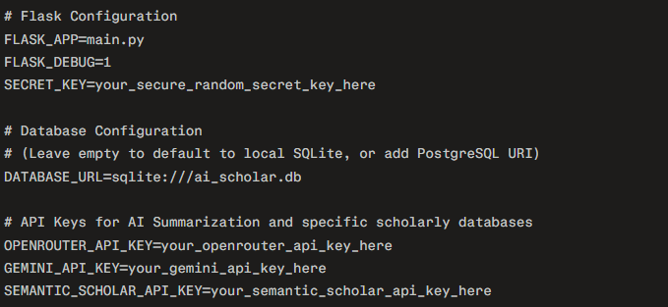
Figure 34 Project .env configuration file setup

Local Development Setup

The following command-line instructions detail the process of retrieving the codebase, isolating the environment, and executing the application.
Step 1: Clone the Source Code Repository
Open a terminal instance and retrieve the project files from GitHub:

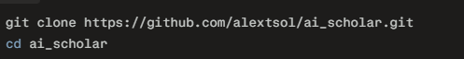
Figure 35 Cloning repository from Github
Step 2: Create and Activate a Virtual Environment
To prevent dependency conflicts with other system applications, it is highly recommended to isolate the project using a Python virtual environment.

Figure 36 Creating virtual Environment

Step 3: Install System Dependencies
With the virtual environment active, install all required Python libraries defined in the system's requirements file:
Figure 37Installing project dependancies
Step 4: Initialize the Database
Generate the database schema and initialize the required tables for user authentication, search history, and saved papers:
Figure 38 Recreating the databases

Step 5: Execute the Application
Initialize the Flask development server:

Figure 39 Executing the python project

Local Development Setup
Once the local server is running, the application will be accessible via standard web browsers.
- Open a modern web browser and navigate to the local host address: http://127.0.0.1:5000
- Upon first launch, navigate to the Registration page to create a local user account.
- Authenticate using the newly created credentials via the Login page.
- The system is now initialized and ready to execute asynchronous, multi-database academic queries.

